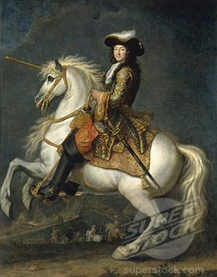
Euro 10
16.2 Guided Notes

Directions: Complete the following section outline by copying it into your notes and filling it out as you read the first 2 ½ pages of Chapter 16, Section 2 (Page 510-512)

France Under Louis XIV

Henry IV Restores Order
- By the 1600’s France was a ___________________, __________________ nation-state ruled by the most powerful monarch in Europe.

Religious Strife
- 1560’s to 1590’s – Religious wars between Catholics and Protestants tore France apart. These French Protestants were called ______________________________________.
- What happened on Saint Bartholomew’s Day?

- Seen as the complete breakdown of order in France

Bringing Peace to a Shattered Land

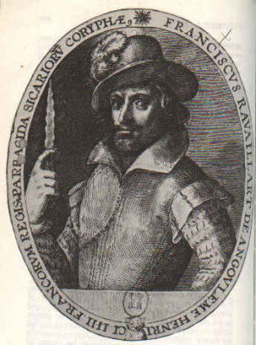

- These changes paved the way for French Kings to build absolute Power
Henry IV’s fanatical Catholic assassin, with the dagger used to kill him.
Cardinal Richelieu Strengthens Royal Authority
- 1610 – Henry IV killed by an assassin
- Cardinal Richelieu sought to destroy the power of the ____________________
and the ____________________.

- When Richelieu died, _____________________________________ took his place as the chief minister for five year old ___________________________________________.

An Absolute Monarch Rises
- The Fronde –

  - Because The Fronde, what did Louis XIV do?

“I Am the State”

- Louis took the sun as the symbol of his absolute power

- During his reign, Louis XIV never called a meeting of the Estates General.

Louis XIV Strengthens Royal Power
- Louis expanded the power of the Crown by appointing royal officials who collected taxes, recruited soldiers, and carried out his policies in the provinces. These people were known as _____________________________________________ and cemented his ties to the middle class.

Colbert Builds France’s Finances
- Jean-Baptiste Colbert was Louis XIV’s finance minister
- He had

- He taxed ______________ goods to ensure that people bought ___________ made goods.
- Because of Colbert’s policies ____________ quickly became the richest country in Europe.
- Yet not even the financial genius of Colbert could produce enough income to support the huge costs of Louis’s court and his many foreign wars

Also, on another piece of paper…
- read infographic on 513 & answer the questions
- Finish reading 514, and answer Assessment question #5:

