Duration of Short-term Memory

Peterson and Peterson (1959)
Saul McLeod updated 2018

Aim:
To investigate the duration of short-term memory.
They aimed to test the hypothesis that information which is not rehearsed is lost quickly from short-term memory
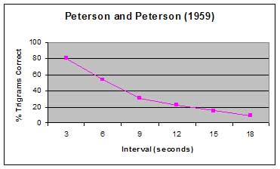

Procedure:
A lab experiment was conducted in which 24 participants (psychology students) had to recall trigrams (meaningless three-consonant syllables, e.g. TGH, CLS).
The trigrams were presented one at a time and had to be recalled after intervals of 3, 6, 9, 12, 15 or 18 seconds.
To prevent rehearsal participants were asked to count backwards in threes or fours from a specified random number until they saw a red light appear. This is known as the brown peterson technique.

Findings:
There was a rapid increase in forgetting as the time delay increased.
    - After 3 seconds 80% of the trigrams were recalled correctly.
    - After 6 seconds this fell to 50%.
    - After 18 seconds less than 10% of the trigrams were recalled correctly.

Conclusion:
Short-term memory has a limited duration (of about 18 seconds) when rehearsal is prevented. It is thought that this information is lost from short-term memory from trace decay.
The results of the study also show the short-term memory is different from long-term memory in terms of duration. Thus supporting the multi-store model of memory.
If a person is not able to rehearse information it will not transfer to their long-term memory store.

Critical Evaluation:
This experiment lacks mundane realism and external validity as they used very artificial stimuli (i.e., people do not try to recall trigrams in real life).
They also only considered short-term memory duration for one type of stimuli. They did not provide information about other types of stimuli such as pictures and melodies.

References
Peterson, L.R., & Peterson, M.J. (1959). Short-term retention of individual verbal items. Journal of Experimental Psychology, 58, 193-198

How to reference this article:
McLeod, S. A. (2018). Peterson and Peterson, 1959. Retrieved from https://www.simplypsychology.org/peterson-peterson.html

