A unique experiment:
The Chinese Imperial Examination System
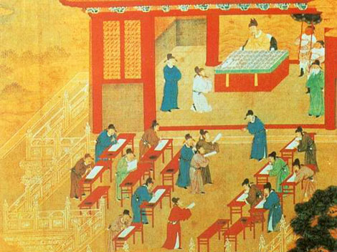
By Justin Crozier
Justin Crozier examines how China's Imperial examination system is a unique attempt in world history to aim for a government of wisdom.
In "On a Chinese Screen", notes from his encounters during a journey on the Yangzte in 1920, the British author Somerset Maugham relayed a conversation he had with a great Confucian philosopher. The Chinese philosopher, who had studied in China and Europe, concludes that all wisdom is to be found within the works of Confucius.
In a bitter mood, the scholar denounced the modern ideas that were sweeping China, and extolled the Confucian system of old: “Do you know that we tried an experiment which is unique in the history of the world? We sought to rule this great country not by force, but by wisdom. And for centuries we succeeded.” The philosopher was surely correct to draw attention to the uniqueness of the Chinese experiment.
China's “Four Great Inventions”, gunpowder, paper, the compass and the printing press, are often trumpeted as the hallmarks of its civilization. But these fruits of Chinese ingenuity are in many ways secondary to the historical development of Chinese civilization and to Chinese society today. Gunpowder may have been discovered in China; but it was chiefly used for fireworks; the value of the compass was squandered by the isolationist tendencies of the Ming Dynasty.
The most truly unique aspect of Chinese culture - and the one with the most powerful legacy - is the Confucian examination system with which the Son of Heaven's empire was staffed with civil servants over the best part of two thousand years. The Imperial examinations represented a remarkable attempt to create an aristocracy of learning, which in itself represent a remarkable advance over the warrior and hereditary aristocracies that dominated in the rest of the world. The Chinese examination system, archaic, laborious and daunting as it may have been, was nevertheless, a glorious attempt at intellectual meritocracy.

The Imperial Examination

Theoretically, any male adult in China, regardless of his wealth or social status, could become a high-ranking government official. Many individuals moved from a low social status to political prominence through success in imperial examination.
The origins of the exam system lie in the Han Dynasty, but the scholarly examinations began to be truly effective under the Tang Dynasty in the 6th century AD. Between the Tang period and the late Ch’ing, the civil service examinations dropped out of use for short periods and underwent occasional reform. But the content remained remarkably constant. The core texts consisted of the Four Books and the Five Classics, works attributed to Confucius and certain of his disciples, along with a number of commentaries on those same works.
From the 1st century AD until the early 20th century, the notorious eight-legged essay, a rigid traditional essay format, was the mainstay of the exam papers. Rote learning (memorization without thinking of meaning or the creation of original ideas) of the Confucian classics was fundamental to success in the exams, and the scholar who obtained the highest degree, the jinshi, would have his memory trained to a tremendous degree. Texts of a total of over 400,000 characters had to be thoroughly memorized, and accurately quoted, if a candidate was to have any hope of progressing to a civil service position. Even at the district level, the pass rate was only 1 or 2%.

Joining the Imperial Civil Service

Each student taking the exam arrived at an examination compound with only a few amenities: a water pitcher, a chamber pot, bedding, food, an ink stone, ink, and brushes. Guards would verify the students' identities and search them for hidden printed materials. Each exam taker spent three days and two nights writing "eight-legged essays" — literary compositions with eight distinct sections — in a tiny room with a small bed, desk, and bench. There were no interruptions in those three days, nor were candidates allowed any communication. If someone died during an exam, officials wrapped his body in a straw mat and tossed it over the high walls that ringed the compound. (Source: China's Examination Hell: The Civil Service Examinations of Imperial China. By Ichisada Miyazaki)
To obtain a civil service post, a candidate had to pass through several stages, starting with preliminary local exams, and progressing, if successful, through to district, provincial, and palace examinations. Exams were held every three years. The district degree was the shengyuan, which entailed exemption from both corporal punishment and the forced labor demands which all Chinese owed to their rulers. Obtaining the degree also gave students the right to wear a scholar's robes, and a small state salary. Essentially, a successful candidate became a member of the noble scholar economic and social class.
To obtain a civil service position, a scholar generally required the juren provincial degree, which would take years of study, and even a brilliant candidate could not reasonably expect to do so before he was thirty. Many candidates who were eventually successful did not achieve office until they had reached their late thirties. The jinshi degrees were prospects for only a very few exceptional scholars. For the very highest government jobs, the best examination essays were selected by the Emperor himself.

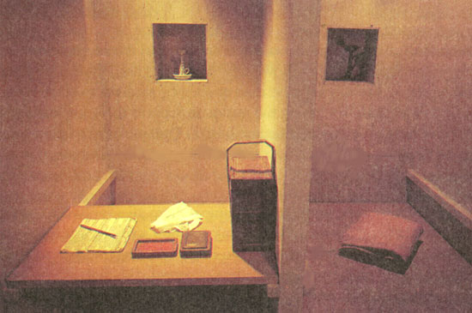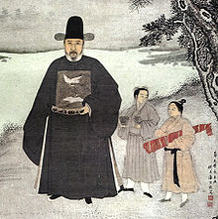

A Meritocratic Aristocracy

The examination based civil service thus promoted stability, social mobility, and a national identity which underlies modern nationalism. The consistency of the content of the examinations meant that the local elites and ambitious would-be members of those elites across the whole of China were taught with the same values. Even though only a small fraction (less than 3 percent) of those who attempted the examinations actually passed them and even fewer received titles, the hope of eventual success sustained their commitment.
Aristocracy-by-examination had far-reaching consequences. A high degree of national stability was ensured despite changes of emperor and dynasty because the civil service, fuelled by the exam system, could continue independently of the imperial regime. Even China's foreign conquerors, the Mongols and the Manchu, realized the benefits of the examination system. Despite demoting Chinese scholars as the “Stinking Ninth” in their social ranking, the Mongols of the Yuan Dynasty retained the system. The Manchu tribesmen who captured Beijing in 1644 to start the Ch’ing Dynasty restored the civil service examinations only two years later, and although they excluded Ethnic Chinese from the highest echelons of the Civil Service, they clearly recognized the adhesive value of the exams in binding the Ethnic Chinese scholar class to the Ch’ing regime.
Most importantly, the civil examinations provided a channel for the aspirations of able men from almost any social level. While there are a few famous literary instances of women dressing up as men to take the exams, in practice, women were entirely excluded from the system. But amongst men, the exams were generally open to all, with the exception of a few classes such as actors and slaves.
Undoubtedly, success in the examinations was easier for the well-off. In the late Ch’ing period in particular, corruption was widespread; examiners could be bribed, and early stages of the exam process could be skipped for a fee. Tutors, books and brushes all cost money, so poor candidates were at a disadvantage even during periods when bribery was frowned upon. Despite this, many poor scholars did succeed in their ambitions. During the Ch’ing period, over a third of jinshi degree holders came from families with little or no educational background. Nor was the system biased towards the inhabitants of the capital. Degrees were awarded to scholars from throughout China.

The Weight of Confucius
While the system could be remarkably meritocratic, it was often attacked for its stultifying emphasis on rote learning. In the Song Dynasty, a scholar argued that:
“A healthy society cannot come about when people study not for the purpose of gaining wisdom and knowledge but for the purpose of becoming government officials”.
In this vein, the Imperial exams have been criticized for dulling China's intellectual growth. By concentrating intellectual activity on the Confucian Classics, the system limited the possibilities for progress. As Western universities began to move away from their own classical tradition to embrace economics, engineering and natural science, China's scholarly efforts languished in the ancient literary past. It is unsurprising that the ingenuity that produced the “Four Great Inventions” could not flourish in such a backward-looking intellectual environment.
While the examinations allowed humble scholars to aspire to ministerial power, they could also prove a powerful source of frustration and bitterness. A rigid examination system does provide an opportunity for intelligent individuals to better themselves; however, the inflexibility inherent to a system used across such a vast nation meant that many talented individuals failed to meet the exacting examination system, and will be left unfulfilled and angry.

From Examination to Rebellion

By 1370, the examinations lasted between 24 and 72 hours, and were conducted in spare, isolated examination rooms. The small rooms featured two boards which could be placed together to form a bed or placed on different levels to serve as a desk and chair. In order to obtain objectivity in evaluation, candidates were identified by number rather than name, and examination answers were recopied by a third person before being evaluated to prevent the candidate's handwriting from being recognized.

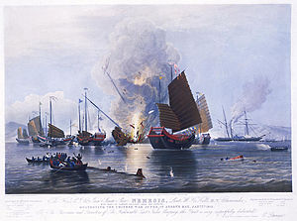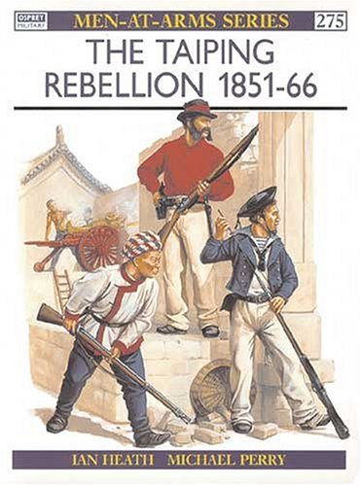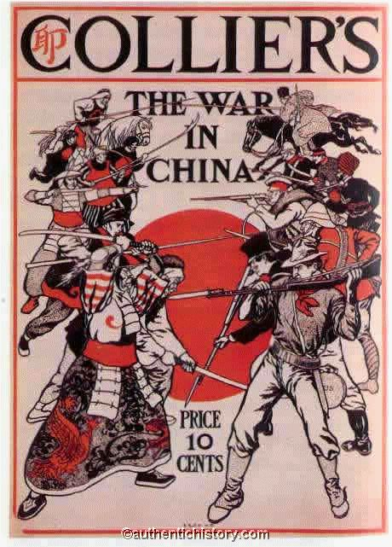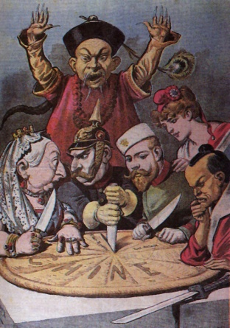
The second bloodiest war in human history, the Taiping Rebellion, which claimed some 20 million lives, had its roots in the frustrations of the civil service exams. Hong Xiuquan failed the shengyuan examinations on four separate occasions. Nursing a grievance against the Confucian state system, Hong's frustration found an outlet when he read a Christian essay condemning the examinations. Prompted by visions and dreams which convinced him that he was the brother of Jesus Christ, he went on to found the Taiping Tianguo, “The Kingdom of Heavenly Peace” and to launch a savage crusade against the Ch’ing “demon devils.” It is surely significant that Hong's first followers were, like him, village schoolmasters whose civil service ambitions had been dashed by their failure in the second round of state examinations.
The Imperial examinations were not the sole factor in the Taiping Rebellion; resentment of Ch’ing rule and the humiliation China suffered in the Opium Wars clearly loomed large in Taiping Rebels’ thoughts. Nevertheless, the frustration that the examination system caused in many aspiring intellectuals was clearly an important part of the growing unrest and disunity that would lead China down the road from greatness to weakness, European and Japanese occupation, civil war, and finally, Mao.

