The Birth and Death of Chinese Naval Power
By Kallie Szczepanski
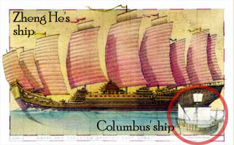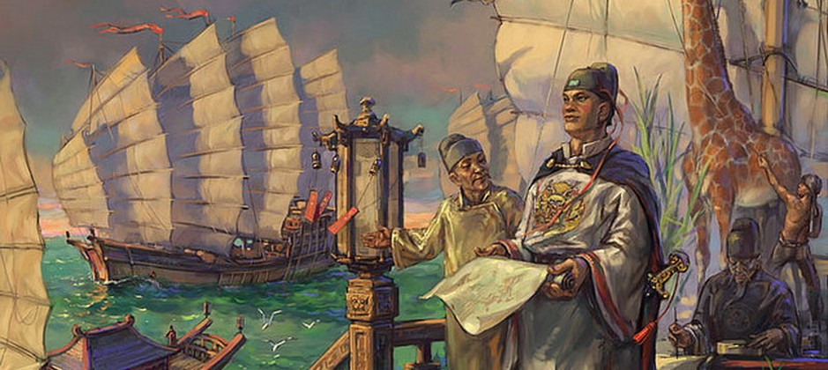
The Ming Dynasty was the ruling dynasty of China for 276 years (1368–1644) following the collapse of the Mongol-led Yuan Dynasty. The Ming, described as "one of the greatest eras of orderly government and social stability in human history", was the last dynasty in China ruled by ethnic Han Chinese.
The Ming Emperors attempted to create a strictly centralized self-sufficient society of rural communities ordered in a rigid, immobile system that would support a permanent class of soldiers. At its height the empire's standing army exceeded one million troops and the navy's shipbuilding yards in Nanjing were the largest in the world. The Emperors’ commands went unchallenged.
The flip side of this unity and self-sufficiency was an isolation that eventually led to cultural and technological stagnation. In 1644 the Ming would be overthrown by Manchus from the north of China (who would set up the Ch’ing Dynasty, which would be China’s last).
Before they vanished, the Ming would create one of the largest naval fleets that history has ever known. Then they would destroy it. This decision has left historians scratching their heads for centuries.
The Birth and Death of the Ming Treasure Fleet
Between 1405 and 1433, Ming China sent out seven gigantic naval expeditions under the command of Zheng He the great Muslim Chinese admiral. These expeditions traveled along the Indian Ocean trade routes as far as Arabia and the coast of East Africa, but in 1433, the government suddenly called them off.
Scholars have wondered for centuries, "What prompted the end of the Treasure Fleet?"
In part, the sense of surprise and even bewilderment that the Ming government's decision elicits in western observers arises from a misunderstanding about the original purpose of Zheng He's voyages. Less than a century later, in 1497, the Portuguese explorer Vasco da Gama would begin Europe’s Age of Exploration by traveling to some of the same places from the west. He called in at the ports of East Africa, and then headed to India, the reverse of the Chinese itinerary. Da Gama went in search of trade, so many westerners assume that the same motives inspired Zheng He's trips.
However, the Ming admiral and his treasure fleet were not engaged in a voyage of exploration, for one simple reason: the Chinese already knew about the ports and countries around the Indian Ocean. Indeed, both Zheng He's father and grandfather used the title hajji, an indication that they had performed their ritual pilgrimage to Mecca, on the Arabian Peninsula. Zheng He was not sailing off into the unknown.
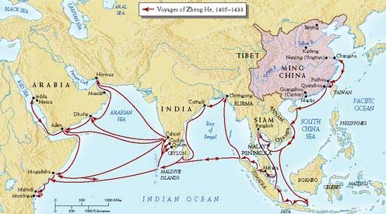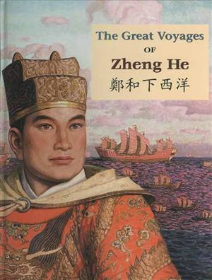 Likewise, the Ming admiral was not sailing out in search of trade. For one thing, in the fifteenth century all the world coveted Chinese silks and porcelain; China had no need to seek out customers - China's customers came to them. For another, in the Confucian world order, merchants were considered to be among the lowliest members of society. Confucius saw merchants and other middlemen as parasites, profiting on the work of the farmers and artisans who actually produced trade goods. An imperial fleet would not sully itself with such a lowly matter as trade. The rulers of the Middle Kingdom (as Chinese referred to their land) felt that they needed nothing from the outside world.
If not trade or new horizons, then, what was Zheng He seeking? The seven voyages of the Treasure Fleet were meant to display Chinese might to all the kingdoms and trade ports of the Indian Ocean world, and to bring back exotic toys and novelties for the emperor. In other words, Zheng He's enormous junks were intended to shock and awe other Asian principalities into offering tribute to the Ming.
So then, why did the Ming dynasty halt these voyages in 1433 then burn the great fleet (according to some sources)?
There were three principle reasons for this decision. First, Emperor Yongle who sponsored Zheng He's first six voyages died in 1424. His son, Emperor Hongle, was much more conservative and Confucianist in his thought. He believed that foreign influence could only weaken and divide China, so he ordered the voyages stopped.
In addition to the political motivation, the new emperor had a financial motivation. The treasure fleet voyages cost Ming China enormous amounts of money; since they were not trade excursions, the government recovered little of the cost. Emperor Hongle inherited a treasury that was much emptier than it might have been, if not for his father's Indian Ocean adventures. China was self-sufficient; it didn't need anything from the Indian Ocean world, so why send out these huge fleets?
Finally, Mongols and other Central Asian peoples made increasingly bold raids on western China, forcing the Ming rulers to concentrate their attention and their resources on securing the country's inland borders. There were also recurrent episodes of plague, which was linked with trade.
For all of these reasons, Ming China stopped sending out the magnificent Treasure Fleet, even going so far as to outlaw large ships. However, it is still tempting to muse on the "what if" questions. What if the Chinese had continued to patrol the Indian Ocean? What if Vasco da Gama's four little Portuguese caravels had run into a stupendous fleet of more than 250 Chinese junks of various sizes, but all of them larger than the Portuguese flagship? How would world history have been different, if Ming China had ruled the waves in 1497-98?

