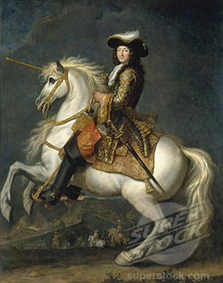
WH10
16.2 Guided Notes

Directions: Complete the following section outline by copying it into your notes journal and filling it out as you read the first 2 ½ pages of Chapter 16, Section 2 (Page 510-512)

France Under Louis XIV

Henry IV Restores Order
- By the 1600’s France was a ___________________, __________________ nation-state ruled by the most powerful monarch in Europe.

Religious Strife
- 1560’s to 1590’s – Religious wars between Catholics and Protestants tore France apart. These French Protestants were called ______________________________________.
- What happened on Saint Bartholomew’s Day?

- Seen as the complete breakdown of order in France

Bringing Peace to a Shattered Land

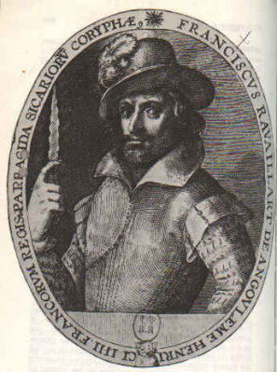

- These changes paved the way for French Kings to build absolute Power
Henry IV’s fanatical Catholic assassin, with the dagger used to kill him.
Cardinal Richelieu Strengthens Royal Authority
- 1610 – Henry IV killed by an assassin
- Cardinal Richelieu sought to destroy the power of the ____________________
and the ____________________.

- When Richelieu died, _____________________________________ took his place as the chief minister for five year old ___________________________________________.

An Absolute Monarch Rises
- The Fronde –

  - Because The Fronde, what did Louis XIV do?

“I Am the State”

- Louis took the sun as the symbol of his absolute power

- During his reign, Louis XIV never called a meeting of the Estates General.

Louis XIV Strengthens Royal Power
- Louis expanded the power of the Crown by appointing royal officials who collected taxes, recruited soldiers, and carried out his policies in the provinces. These people were known as _____________________________________________ and cemented his ties to the middle class.

Colbert Builds France’s Finances
- Jean-Baptiste Colbert was Louis XIV’s finance minister
- He had

- He taxed imported goods to ensure that people bought French made goods.
- Because of Colbert’s policies France quickly became the richest country in Europe.
- Yet not even the financial genius of Colbert could produce enough income to support the huge costs of Louis’s court and his many foreign wars

