WH10: Friday Review Scientific Revolution & Introduction

Introduction
In this class we will use each Friday to review the week’s topics. This will include a few review questions (use the book to answer them) and some terms and people that should be added to your Field Guide (Automatic 5% Extra Credit if all completed – plus they will help you study!). You should hole-punch each notecard and add it to your ring. Often times, as you work on completing your Friday work I will do a journal check. WHATEVER YOU DO NOT COMPLETE IN CLASS SHOULD BE DONE AS HOMEWORK OR DURING TUTORIAL/AT.
Terms
For each of the following terms you should write it on one side of your notecard and define it IN YOUR OWN WORDS and any other relevant information on the back of the notecard.
Heliocentric Geocentric
People
For each of the following people you should cut out their picture and paste it to your notecard and on the back write their significance (why are they important) and any other relevant information. Make sure you cut the person’s name out along with the picture!
____________________________________________________________________________________________________________________________
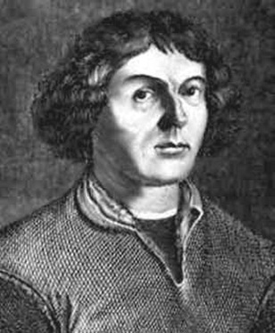
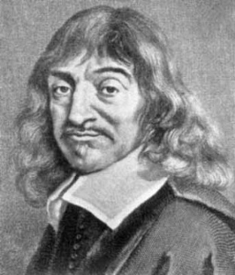
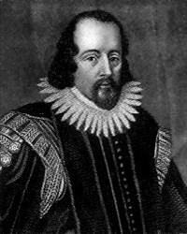
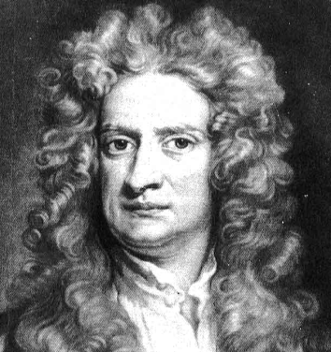
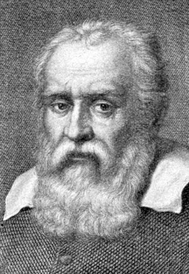
Galileo Galilei Nicolaus Copernicus Sir Isaac Newton Renè Descartes Sir Francis Bacon

Review Questions (Chapter 13, Section 5) – Complete in your in-class journal and have stamped when you are done.
- Why did the theories of Copernicus and Galileo threaten the Catholic Church?
- How did Galileo improve upon the theories of Copernicus?
- How did the Scientific Revolution change the way that people thought about the natural world (natural world = nature)?
  - How might this new way thinking be applied to the social world (governments, economics, social systems, etc…)

