WH9: Friday Review Islam, Crusades, Black Death

Terms
For each of the following terms you should write it on one side of your notecard and define it IN YOUR OWN WORDS and any other relevant information on the back of the notecard.
Qur’an Jerusalem Mecca Plague Crusader
People
For each of the following people you should cut out their picture and paste it to your notecard and on the back write their significance (why are they important) and any other relevant information. Make sure you cut the person’s name out along with the picture!

Muhammad Allah Saladin Pope Urban II
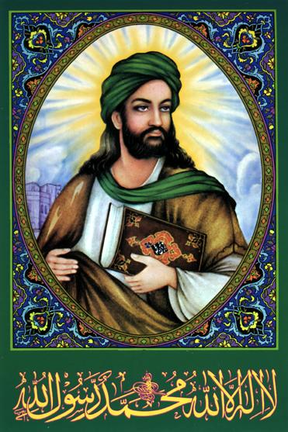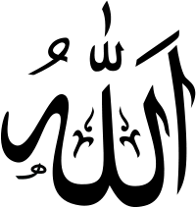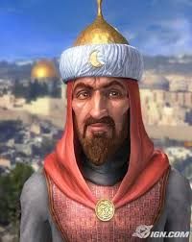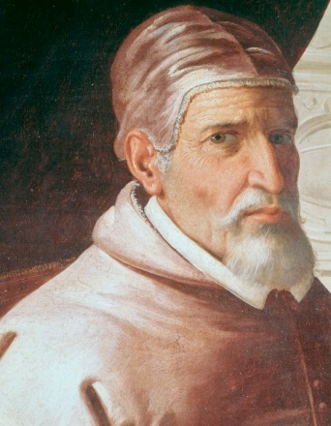

“For Your Review” Questions (Chapter 8, Sections 3 & 5, Chapter 10, DBQ Docs)—Complete in your journal and have it stamped when your done.
- Describe how and where the religion of Islam sprouted and spread, as well as some of the factors that helped it spread so quickly.
- What is the Ka’ba and how is it still important to Muslims today?
- How did the worlds of Christians and Muslims begin to come together and what long-lasting event (more than 200 years) did it lead to?
- Because of the level of success experienced by Christian kings and crusaders, how did Europeans begin to shift their military, political, and economic priorities?
- Why did the Black Death have such an impact on European culture?

