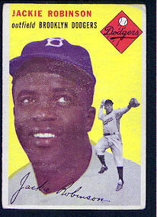
Absolute Monarch Baseball Cards:
All the fun of glorified Dictators and America’s favorite trading cards!

Directions: You are the manager of the “Absolutists.” Your task is to market your lineup to fans throughout the land through a team pack of baseball cards. You can work with up to two other coaches to create your pack of cards. Help people understand how their actions and policies contribute to the revolutions of the 18th & 19th centuries. You should use the text book (pg. 502-539), lecture, & library sources to help you create the cards.
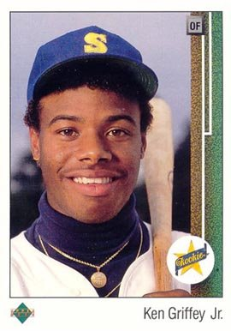

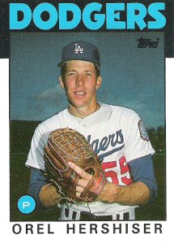
Required Elements:
- Front:
  - A picture depicting the Absolute Monarch
  - The Monarchs Name
  - What country they ruled
  - Any symbol that represented that Monarch, etc…
  - BE CREATIVE!
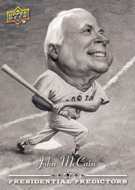
- Back: Statistics and important facts
  - What years they ruled.
  - Any wars they fought during their reign.
    - Include who the war was against and if they won or not.
  - 2-3 Career Highlights
    - Most important events, accomplishments or legacy of that Monarchs reign.
- Required Monarchs: (One card for each of the following)
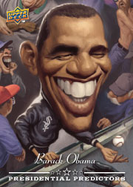
  - Phillip II (pg. 504-508)
  - Maria Theresa (pg. 528)
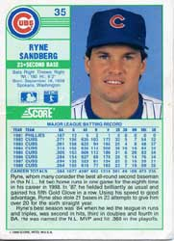
  - Frederick the Great (pg. 528-529)
  - Peter the Great (pg. 530-533)
  - Catherine the Great (pg. 533-535)
  - Louis XIV (14th) (pg. 510-515)
  - Charles I (pg. 516-519)
  - Charles II (520-521)
  - James II (pg. 521-524)
- Bench Players—not monarchs, still played a large part!
  - Oliver Cromwell (pg. 519-520)
  - Cardinal Richelieu (pg. 511)
  - Jean-Baptiste Colbert (pg. 512)
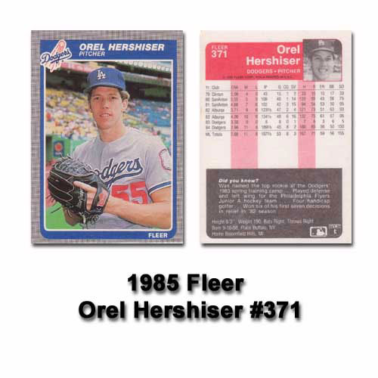
- Scoring: Each card will be worth 5 points each.
- DUE: __________________________________
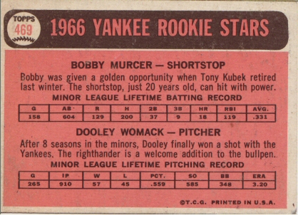
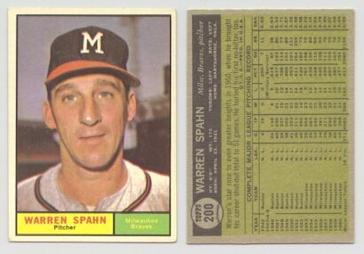

Absolute Monarch

Baseball Card Rubric

 | Excellent (3) | Good (2) | Fair (1) | Unsatisfactory (.5)
Content | Baseball card presents the basic facts (country, years of reign, wars, etc…) of the Monarch accurately.  The most important issues and events are addressed.  Issues and events are portrayed in a historically accurate way with proper names and dates. | Baseball card presents the basic facts (country, years of reign, wars, etc…) of the Monarch accurately.  Most of the most important issues and events are addressed.  Issues and events are portrayed in a mostly historically accurate way with proper names and dates. | Baseball card presents the basic facts (country, years of reign, wars, etc…) of the Monarch somewhat accurately.  Some of the most important issues and events are addressed.  Issues and events are portrayed in a somewhat historically accurate way with some proper names and dates. | Baseball card presents the basic facts (country, years of reign, wars, etc…) of the Monarch inaccurately.  Very few if any of the most important issues and events are addressed.  Issues and events are portrayed in a historically inaccurate way with very few proper names and dates.
Completeness | Card has a color picture of the Monarch.  Mentions the country the monarch ruled and any wars they fought.  Explains major events, accomplishments/legacy of the Monarch. | Card has a color picture of the Monarch.  Mentions the country the monarch ruled and any wars they fought.  Explains most major events, accomplishments/legacy of the Monarch. | Card has a partially colored picture of the Monarch.  Vaguely mentions the country the monarch ruled and any wars they fought.  Explains a few major events, accomplishments/legacy of the Monarch. | Card has a picture of the Monarch with no color.  Does not mention the country the monarch ruled, the wars they fought in or both.  Explains very few major events, accomplishments/legacy of the Monarch.
Creativity and Neatness | Card is neat, planed out and colored. It is clear that a lot of time and effort was taken to create drawings.  There are no smudges, creases or tears on the paper.  Pictures creatively present history. | Card is fairly neat, planed out and colored. It is clear that some time and effort was taken to create drawings.  There are no smudges, creases or tears on the paper.  Pictures creatively present history. | Card is somewhat, planed out and colored. It is clear that drawings were created quickly and with little care.  There are some smudges, creases or tears on the paper.  Pictures have minimal creativity. | Card has little evidence of planning or color. It is clear that drawings were created quickly and with little care.  There are many smudges, creases or tears on the paper.  Pictures have minimal creativity.

Name:______________
Period:_____________
What did we learn follow-up
Absolute Monarchs

- What were 3 similarities between the Monarchs of Europe? Give an example for each one. (How did they treat their people, or make sure they knew who was boss)

- (Soc/Std 5.1.1) What were the reasons that Monarchs acted the way did, and what were the consequences of their actions?

