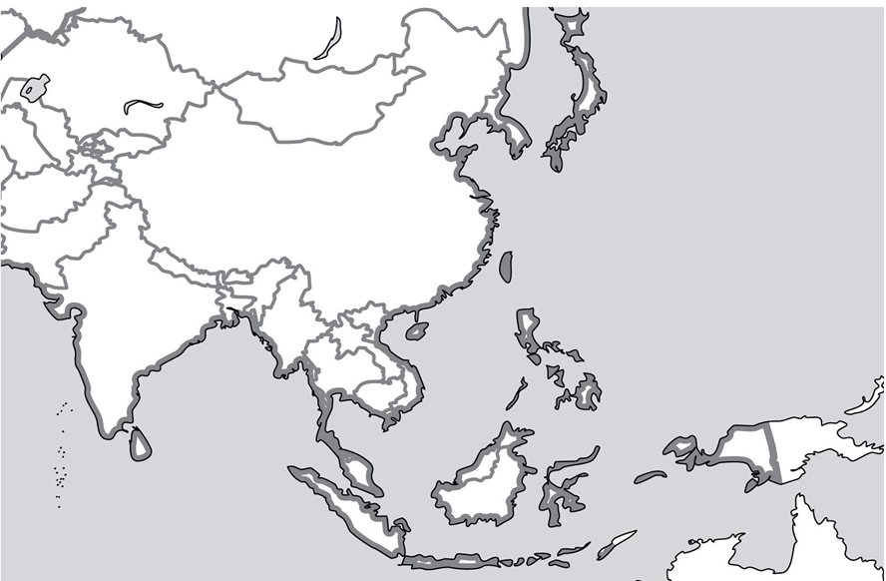
Asia: Political Map
Label the following countries: China, Russia, India, Afghanistan, Tajikistan, Kirgizstan, Kazakhstan, Mongolia, North Korea, South Korea, Japan, Brunei, Taiwan, the Philippines, Malaysia, Indonesia, Singapore, Thailand, Cambodia, Laos, Vietnam, Myanmar (Burma), Bangladesh, India, Nepal, Bhutan, Pakistan, Papua New Guinea, Australia, East Timor, Sri Lanka, Maldives.
Asia: Physical Map
Draw and label the following: the Ganges River, the Yellow (Huang) River, the Mekong River, the Himalayas, the Indus River, the Yangtze River, the South China Sea, the East China Sea, the Andaman Sea, the Indian Ocean, the Arabian Sea, the Gulf of Thailand, the Tibetan Plateau, the Gobi Desert, and the Great Wall of China, the Silk Road(s).

