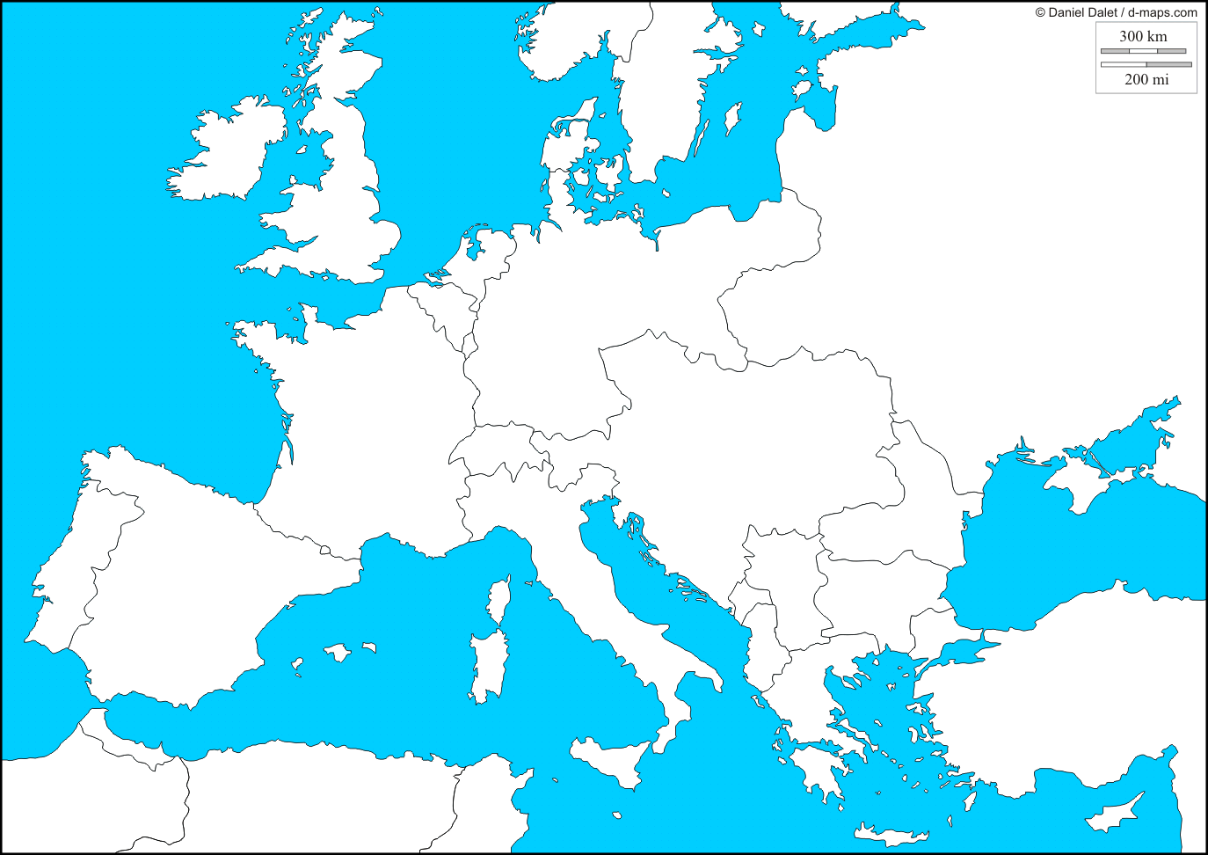

Europe, 1914 – The eve of World War I