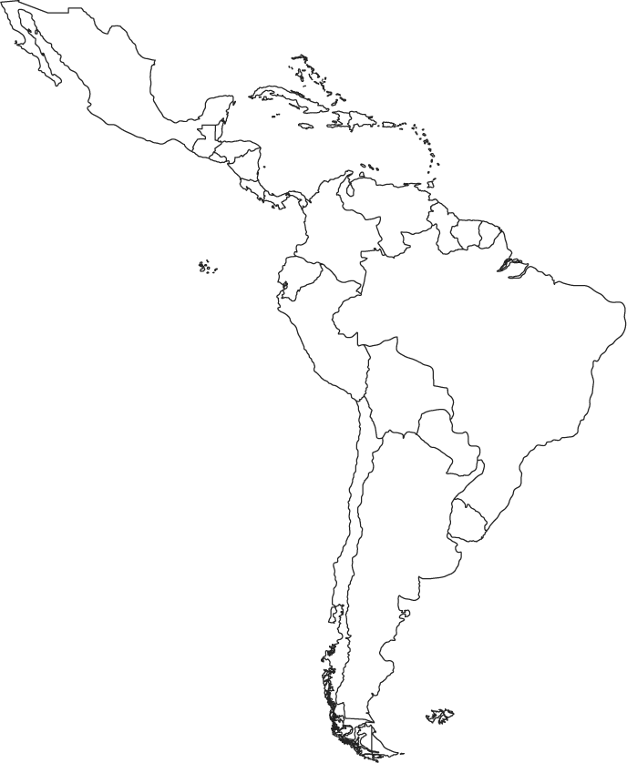
Physical/Political Map of Central and South America (Use The Nystrom Desk Atlas: pages 82-93)
- Political Map of Central and South America. Label all of the countries (in the Caribbean please label Cuba, Haiti, and the Dominican Republic).
Also: Outline and label the areas of influence of the Maya, Aztec, and Inca civilizations.
Physical/Political Map of Central and South America (Use The Nystrom Desk Atlas: pages 82-93)

- Physical Map of Latin America
Use color to represent elevation and vegetation. Color and label all of the following physical landforms: the Atlantic Ocean, the Pacific Ocean, the Atacama Desert, the Pampas, the Amazon River, the Amazon Basin, the Llanos, the Orinoco River, The Andes, Patagonia, The Sierra Madres (Occidental and Oriental), The Yucatan Peninsula, the Caribbean sea, and the Gulf of Mexico.

Question: How does the physical geography of the three main civilizations of the Americas compare? What impact does this have on the elements of culture that we are witnessing?

Compare what we know about the land use of these early civilizations to what trends you are seeing on the maps in the atlas.

Maya—

Aztec—

Inca—

On page 91, do you see any correlation between current trends and previous learning from this unit?

In looking at the cross-section of South America (92), do you notice any advantages or disadvantages that might be similar to other civilizations we’ve examined?

