China Maps, Political and Physical
Name: _____/ 40
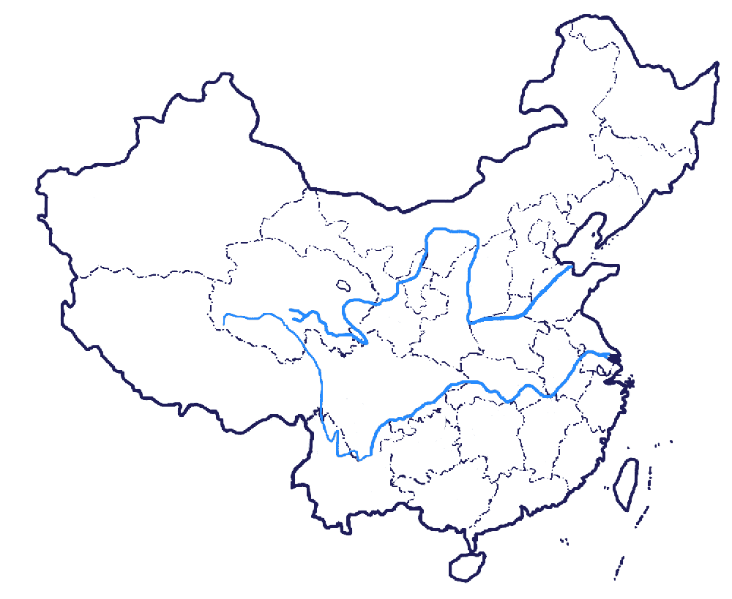
Political and Population. Label 15 major cities in China (choose and number them). Then shade or color the map to show population density (see atlas page 129 or use the Internet).

Physical. Trace or draw or shade (if necessary) and label and number an assortment of these (20 total; you choose):
Oceans, Bays, Gulfs, Seas, Deserts, Plains, Plateaus, Basins and Depressions, Mountains, Rivers, Lakes

