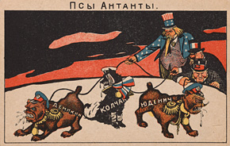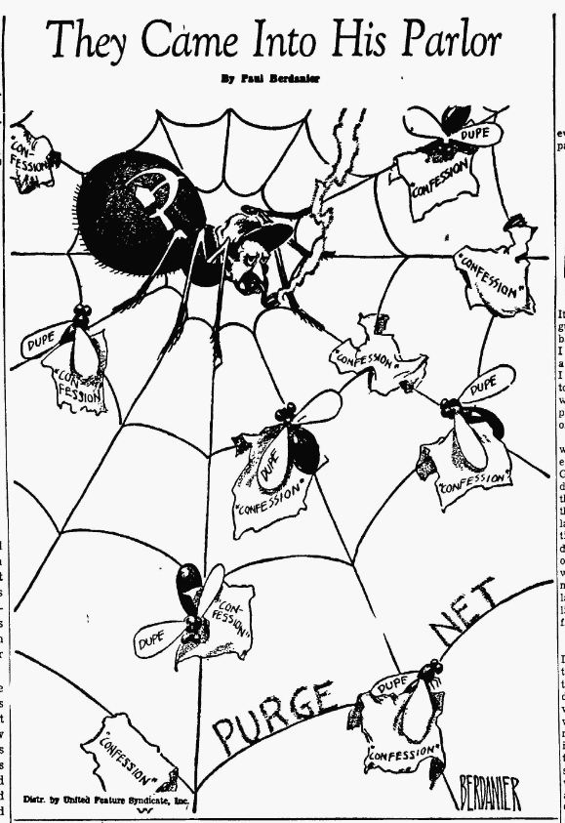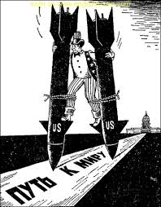
2
3
1
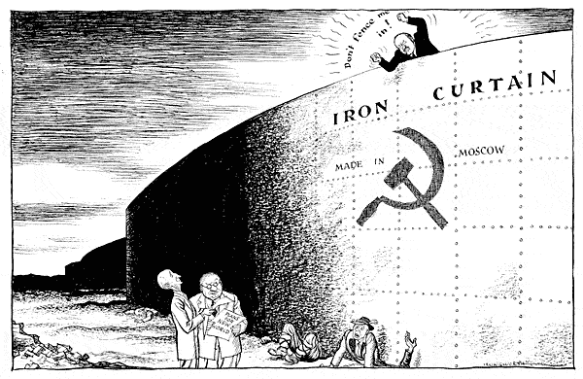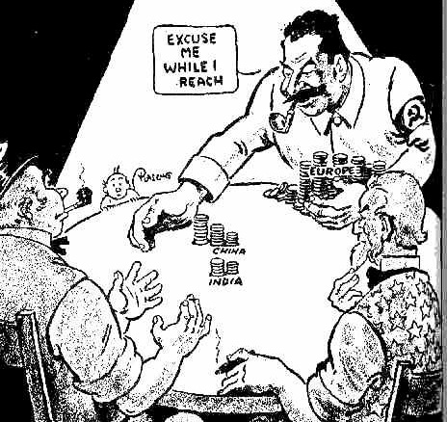
5
4
Analyze the political cartoons above and describe in a thesis-driven paragraph the connection you are seeing between what we have discussed thus far about the Cold War, as well as previous historical background if appropriate using specifics from at least three images to support your thoughts.

