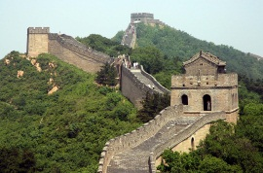
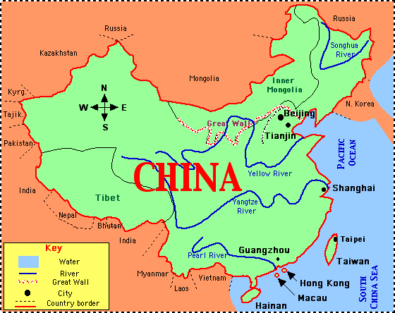
Name (#): _____________________________
Block: ___
Date: _______________________

China: Engineering an Empire

Collect information on the following topics.

Qin Dynasty

3 facts
Li Bing and Qin Engineering

2 facts
Shi Huangdi  4 facts | - Early life-  - Ruling style (how did he get/keep power?)  - Terra Cotta army (tomb)-  - Results (what happened at the end of his life?)-
The Great Wall

3 facts
Han Dynasty

2 facts
Yang Di and  Canal Engineering  2 facts | “An engine of cultural development.”
The Ming Dynasty and Navy  3 facts | 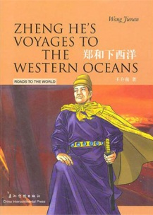  Zheng He-

