Europe 1914
WORLD WAR I: Map Activity
Instructions: Using the maps pages 817, complete the map of Europe and answer the questions from below.

Identify Countries, Bodies of Water, and Cities (with a dot): Label NEATLY on map.

- Italy  - France  - Spain  - Netherlands  - Belgium  - Denmark  - Portugal | - Germany  - Austria-Hungary  - Great Britain  - Switzerland  - Serbia  - Russia  - Ottoman Empire | - Mediterranean Sea  - North Sea  - Baltic Sea  - Atlantic Ocean  - English Channel  - Alsace-Lorraine
- London  - Constantinople  - Vienna | - Paris  - Rome | - Berlin
Coloring: Color in the Countries; use colored pencils or markers!!!

- Allied Powers: Green
- Central Powers: Red
- Neutral Countries: Yellow (All neutral countries – even ones that eventually choose sides)

Questions – Answer and title it “WWI Map Questions”
1. Why might Germany worry about an alliance between France and Russia?

2. What countries make up the Balkans? Why do you think this area may be important?

3. Which alliance do you think had the greatest military advantage in 1914?

4. Why might the neutral countries be important to the war?

5. List the neutral countries that joined the Allies and the countries that joined the Central Powers.
6
1
5
8
4
2
3
7

THE HOUSE OF CARDS
6. Looking at your map,
try to figure out what country
each person in The House of Cards represents.
Write the number and the name of the country
And person next to it.

10

9

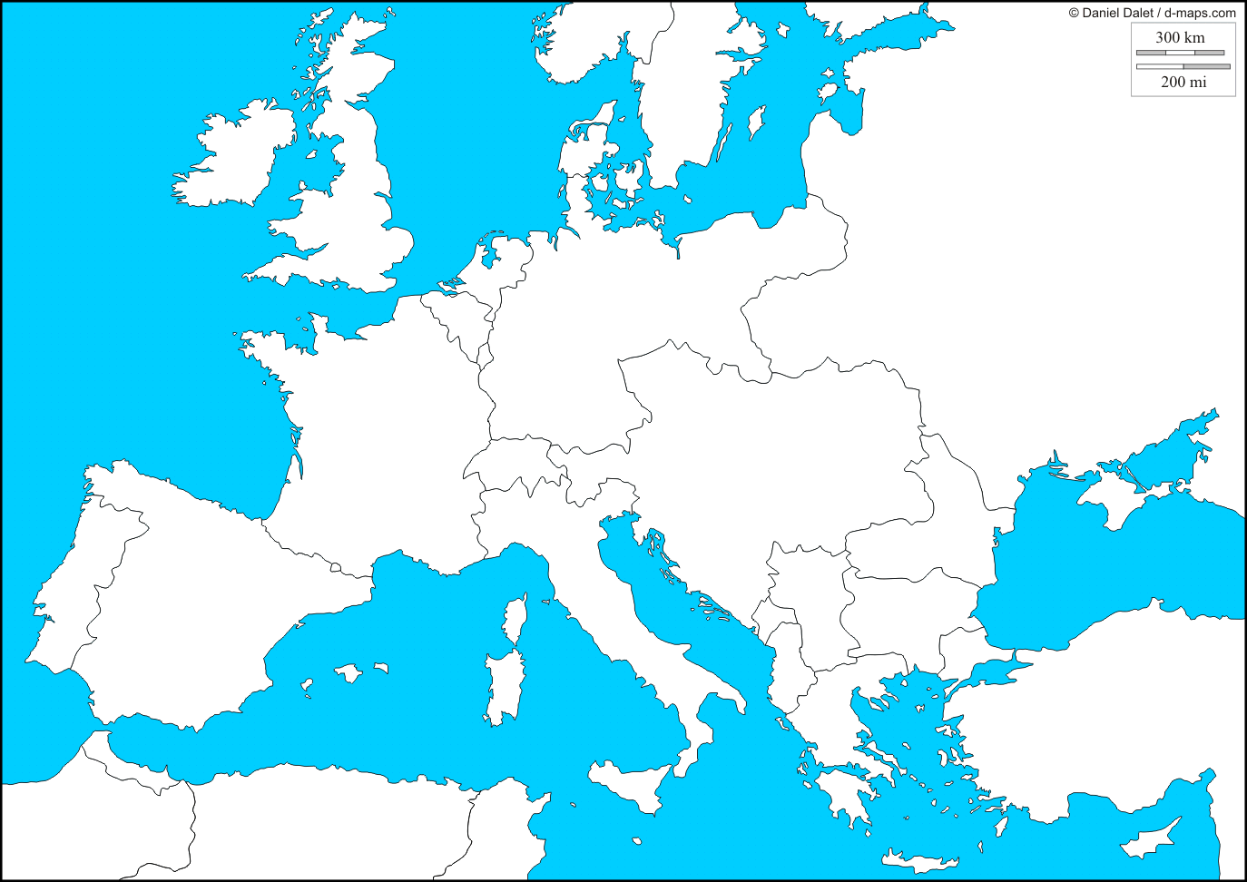
Europe, 1914 – The eve of World War I

