Declaration of the Republic and the Trial of Louis
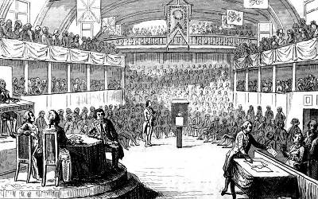
Following the arrests of Louis XVI and Marie Antoinette, the Legislative Assembly disbanded and replaced itself with a new political body named the National Convention. The first act of the latter was to declare France as a republic on September 21, 1792. Meanwhile, the French military had halted the foreign invasion and pushed back the Austrians and Prussians. Louis was charged with treason. The vote at the end of the trial was unanimous: Louis was guilty. The vote on the death penalty was much closer but it passed. On January 21, 1793, Louis was driven through the streets of Paris to a guillotine and decapitated. Marie Antoinette had a short trial next. She was accused of numerous crimes, many of them based on rumors. On October 16, she too was found guilty and guillotined the same day.

Reign of Terror
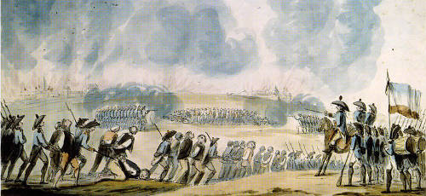
The new National Convention was dominated by the Committee of Public Safety. One man in particular, Maximilien Robespierre came to dominate the Committee and established himself as the leader of the so-called Reign of Terror. Robespierre wanted to rid France of all enemies of the Revolution and to protect the “virtue” of the nation. From September 1793 to July 1794, an estimated 16,000 people were guillotined. Many radicals were executed along with moderates. Most leaders of the French Revolution were now either dead or had fled the republic. Opposition to Robespierre grew both in the Committee of Public Safety and within the National Convention. The execution of popular Committee member George-Jacques Danton and Robespierre proclaiming himself as the leader of a new religion of the Supreme Being caused much resentment. On July 27, 1794, Robespierre was arrested. He was guillotined the following day.

Directory and the Rise of Napoleon
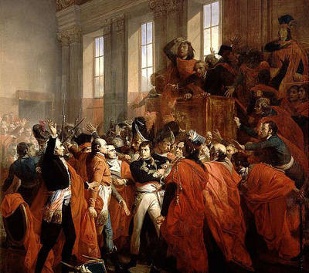
After the dramatic fall of Robespierre, the National Convention created a new constitution for France that was implemented in 1795. Leading the new government was the Directory consisting of an executive council of five members. Almost from the start, the Directory became mired in corruption, political conflict, financial problems and depended on the army to remain in power. In 1799, a successful military commander named Napoleon Bonaparte returned from a military expedition in Egypt and ousted the Directory. Napoleon established what he called the Consulate and himself as the First Consul.

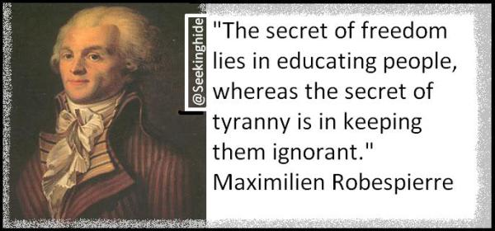
Robespierre was a French lawyer and politician who became one of the most influential figures of the French Revolution.
Maximilien Marie Isidore de Robespierre was educated as a lawyer Paris. He was elected a deputy of the estates-general (a form of parliament, but without real power) that met in May 1789, and subsequently served in the National Constituent Assembly.
Robespierre became increasingly popular for his attacks on the monarchy and his advocacy of democratic reforms. In April 1790, was elected president of the powerful Jacobin political club. After the downfall of the monarchy in August 1792, Robespierre was elected first deputy for Paris to the National Convention. The convention abolished the monarchy, declared France a republic and put the king on trial for treason, all measures strongly supported by Robespierre. The king was executed in January 1793.
In the period after the king's execution, tensions in the convention resulted in a power struggle between the Jacobins and the more moderate Girondins. The Jacobins used the power of the mob to take control and the Girondin leaders were arrested. Control of the country passed to the Committee of Public Safety, of which Robespierre was a member. He rapidly became the dominant force on the committee.
Against a backdrop of the threat of foreign invasion and increasing disorder in the country, the committee began the 'Reign of Terror', ruthlessly eliminating all those considered enemies of the revolution.
The intensification of the 'Reign of Terror' and Robespierre's autocracy made him increasingly unpopular. A conspiracy was formed to overthrow Robespierre. On 27 July 1794, he was arrested after a struggle. The following day Robespierre, wounded from a bullet to the jaw, and 21 of his closest supporters were executed at the guillotine.

Crossbar
The National Razor
The Crossbar contains the release mechanism for the Mouton. A metal bar connects the Delic to the rocker arm. When pulled down it opens the jaws of the grab, and the Mouton falls down. Spring steel keeps the parts in the right position.

Mouton & Blade
The Mouton is a weight, which on four wheels, runs in the grooes of the uprights. The blade is attached to the mouton with three bolts. On the top of the mouton is a hook for the rope, and a spike with an arrowhead, which fits in the sprung grab. The mouton weighs 30kg, and the blade 7kg+ the three bolts, about 1kg each. It makes a total weight of 40kg.

Declic & Release Handle
The declic is the handle that the executioner pulls down to release the mouton. A metal bar that runs inside the upright connects the declic to the rocker arm in the crossbar.

Lunette
This part of the guillotine is made of two wooden pieces, one fixed and one moveable. The lunette is copper lined at the side towards the blade.

Bascule
At the start of the execution, this teeterboard stands in vertical position. The victim is pushed against it, and is tilted into horizontal position, face down with his neck in the lunette between the uprights.
On the side of the bascule is a sort of table which is also hinged to make it easy to pull the headless body into a big basket after the execution.
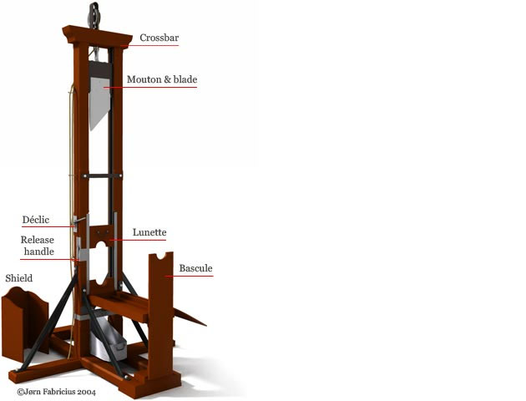
The Machine Open to All
The guillotine may have been similar in form and function to other, older, devices, but it broke new ground: an entire country officially, and unilaterally, adopted this decapitation machine for all of its executions. The same design was shipped out to all the regions, and each was operated in the same manner, under the same laws; there was supposed to be no local variation. Equally, the guillotine was designed to administer a fast and painless death to anyone, regardless of age, sex or wealth, an embodiment of such concepts as equality and humanity. Before the French Assembly's 1791 decree beheading was usually reserved for the rich or powerful, and it continued to be in other parts of Europe; however, France's guillotine was available to all.

