WH10: Friday Review Absolutism

Terms
For each of the following terms you should write the term on one side of your notecard and then on the back, define it IN YOUR OWN WORDS and add any other relevant information.
Absolute Monarch Divine Right Balance of Power Limited Monarchy St. Petersburg

People
For each of the following people you should cut out their picture and paste it to your notecard and on the back write their significance (why are they important) and any other relevant information. Make sure you cut the person’s name out along with the picture!
____________________________________________________________________________________________________________________________
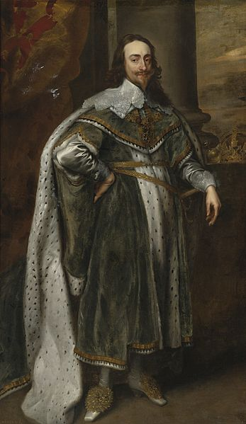
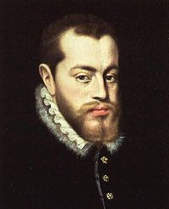
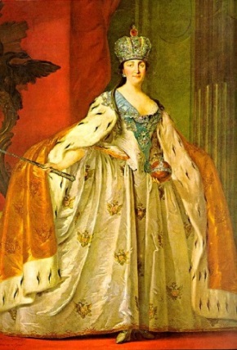
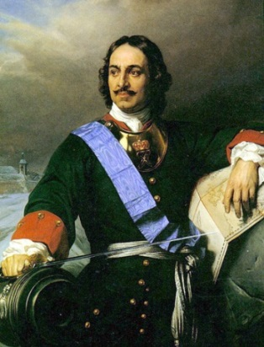
Peter The Great Catherine The Great Charles I Queen Maria Theresa Philip II 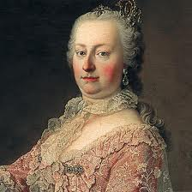

_____________________________________________________________________________________________________________________________
Review Questions (Chapter 16, all sections except Section 2) – Complete in your in-class journal and have stamped when you are done.
CUT THESE QUESTIONS OUT AND PASTE THEM INTO YOUR JOURNAL (OR REWRITE THEM)
1. What was the Spanish Armada, and how did its defeat lead to the decline of the Spanish Empire?
2. How did the Glorious Revolution limit royal power in England?
3. What reforms did Peter the Great carry out?
4. How were Catherine the Great’s goals similar to those of Peter?
5. What are the 3 Critical Attributes of an absolute ruler? For each attribute give an example of a monarch who demonstrates the attribute

