WH10: Friday Review Absolutism, Louis XIV

Terms
For each of the following terms you should write the term on one side of your notecard and then on the back, define it IN YOUR OWN WORDS and add any other relevant information.

Versailles Intendants The Fronde Edict of Nantes Huguenots

People
For each of the following people you should cut out their picture and paste it to your notecard and on the back write their significance (why are they important) and any other relevant information. Make sure you cut the person’s name out along with the picture!
____________________________________________________________________________________________________________________________
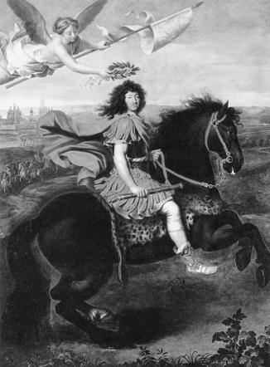
Louis XIV Jean-Baptiste Colbert Cardinal Richelieu Frederick the Great

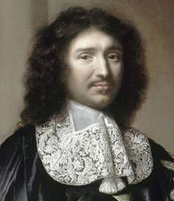
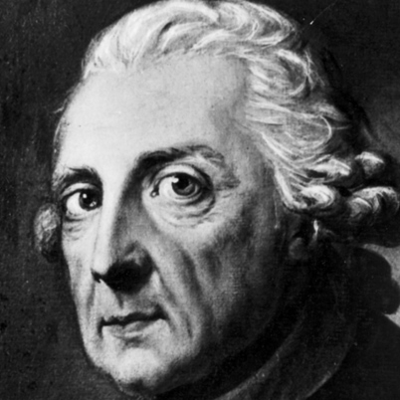

_____________________________________________________________________________________________________________________________
“For Your Review” Questions (Chapter 16, section 2) – Complete in your in-class journal and have stamped when you are done.
CUT THESE QUESTIONS OUT AND PASTE THEM INTO YOUR JOURNAL (OR REWRITE THEM)
- Following the wars of religion, the Fronde, and Louis XIV taking the throne, what did Louis do with the Edict of Nantes? WHY?
- In what ways was Versailles a symbol of Louis XIV’s absolute power?
- What impact did Cardinal Richelieu have on the power of French Kings?
- In what ways was Jean-Baptiste Colbert important to the success of France and Louis XIV building, establishing, and continuing his power?
- Compare and contrast the rule of Louis XIV to that of Frederick the Great of Prussia.

