Friday Review #4—Enlightenment Philosophers
Terms
For each of the following terms you should write the term on one side of your notecard and then on the back, define it IN YOUR OWN WORDS and add any other relevant information.
State (Law) of Nature Social Contract Natural Rights Leviathan Laissez-Faire
People
For each of the following people you should cut out their picture and paste it to your notecard and on the back write their significance (why are they important) and any other relevant information. Make sure you cut the person’s name out along with the picture!
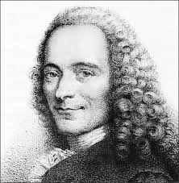 |  |  | 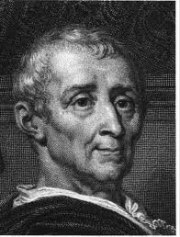 |  | 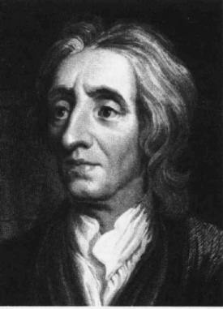 |  |  | 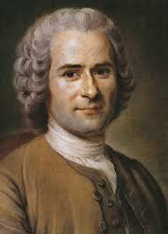 |  |  | 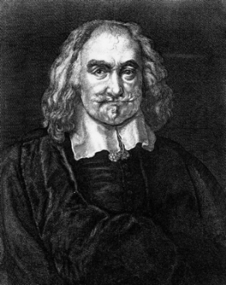
Voltaire Montesquieu John Locke Rousseau Thomas Hobbes
______________________________________________________________________________________________________________________
Review Questions (Chapter 17, Section 2) – Complete in your in-class journal and have stamped when you are done.
CUT THESE QUESTIONS OUT AND PASTE THEM INTO YOUR JOURNAL (OR REWRITE THEM).
- As Enlightenment ideas spread across Europe, what cultural and political changes took place?
- How did ideas of a “just society” change during the Age of Reason?
- Explain the differences between baroque and rococo, and how these styles were reflected in art.
- What did Frederick the Great mean when he said, “In my kingdom, everyone can go to heaven in his own fashion”?
- What actions might peasants take as they learn more about ideas such as equality?

