Name: __________________
Thesis:
If you can convince people that what they are doing is wrong, they will stop doing it.
Circle one: Agree Disagree
Block: ___
Date: _____________
M.K. Gandhi
Creative Rebel
Use the reading to answer the following questions:

- What authors and religious ideas influenced Gandhi? (there are at least 4 mentioned in this article)

- What is your favorite of Gandhi’s nicknames?
- Why did Gandhi go to England?
- Why did Gandhi go to South Africa?
- What happened to Gandhi in South Africa?

- What did Gandhi do in South Africa?
- Why did poor people in South Africa and India come to respect and unite around Gandhi’s leadership?

- What is Satyagraha?

- What does a Satyagrahi do?
- What does a Satyagrahi not do?
- What were Indians protesting in South Africa?
- How did Satyagraha work in South Africa?
- What do you think is the hardest part of being a Satyagrahi?
- Could you do it? Why or why not?

Who Was Gandhi?
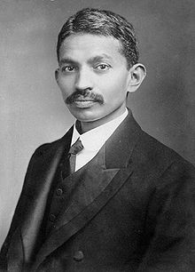
Mohandas Gandhi is considered the father of the Indian independence movement. Gandhi spent 20 years in South Africa working to fight discrimination. It was there that he created his concept of satyagraha, a non-violent way of protesting against injustices. While in India, Gandhi's obvious virtue, simplistic lifestyle, and minimal dress endeared him to the people. He spent years working diligently to both remove British rule from India as well as to better the lives of India's poorest classes. Many civil rights leaders, including Martin Luther King Jr., used Gandhi's concept of non-violent protest as a model for their own struggles.
Dates:
October 2, 1869 - January 30, 1948
Also Known As:
Mohandas Karamchand Gandhi, Mahatma ("Great Soul"), Father of the Nation, Bapu ("Father"), Gandhiji

Gandhi's Childhood
Mohandas Gandhi was the last child of his father (Karamchand Gandhi) and his father's fourth wife (Putlibai). During his youth, Mohandas Gandhi was shy, soft-spoken, and only a mediocre student at school. Although generally an obedient child, at one point Gandhi experimented with eating meat, smoking, and a small amount of stealing -- all of which he later regretted. At age 13, Gandhi married Kasturba (also spelled Kasturbai) in an arranged marriage. Kasturba bore Gandhi four sons and supported Gandhi's endeavors until her death in 1944.

Off to London
In September 1888, at age 18, Gandhi left India, without his wife and newborn son, in order to study to become a barrister (lawyer) in London. Attempting to fit into English society, Gandhi spent his first three months in London attempting to make himself into an English gentleman by buying new suits, fine-tuning his English accent, learning French, and taking violin and dance lessons. After three months of these expensive endeavors, Gandhi decided they were a waste of time and money. He then cancelled all of these classes and spent the remainder of his three-year stay in London being a serious student and living a very simple lifestyle.
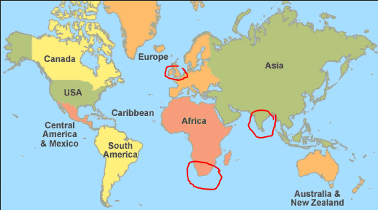
In addition to learning to live a very simple and frugal lifestyle, Gandhi discovered his life-long passion for vegetarianism while in England. Although most of the other Indian students ate meat while they were in England, Gandhi was determined not to do so, in part because he had vowed to his mother that he would stay a vegetarian. In his search for vegetarian restaurants, Gandhi found and joined the London Vegetarian Society. The Society consisted of an intellectual crowd who introduced Gandhi to different authors, such as Henry David Thoreau and Leo Tolstoy. It was also through members of the Society that Gandhi began to really read the Bhagavad Gita, an epic poem which is considered a sacred text to Hindus. The new ideas and concepts that he learned from these books set the foundation for his later beliefs.
Gandhi successfully passed the bar on June 10, 1891 and sailed back to India two days later. For the next two years, Gandhi attempted to practice law in India. Unfortunately, Gandhi found that he lacked both knowledge of Indian law and self-confidence at trial. When he was offered a year-long position to take a case in South Africa, he was thankful for the opportunity.

Gandhi Arrives in South Africa
At age 23, Gandhi once again left his family behind and set off for South Africa, arriving in British-governed Natal in May 1893. South Africa at that time (and today) has a large Indian population. The British used South Africans as laborers and merchants. The British practiced a policy of divide and control in their colonies, encouraging the movement of people from one colony to another. They found Indians easier to control than native Africans because they were so far from their home. Gandhi was to be one of the only Indian lawyers in South Africa.

It was in South Africa that Gandhi transformed from a very quiet and shy man to a resilient and potent leader against discrimination. The beginning of this transformation occurred during a business trip taken shortly after his arrival in South Africa.
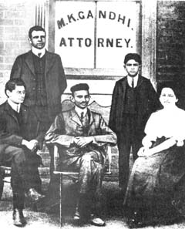
Gandhi had only been in South Africa for about a week when he was asked to take a long train trip. It was to be a several day trip. When Gandhi boarded the first train of his journey at the Pietermartizburg station, railroad officials told Gandhi that he needed to transfer to the third-class passenger car. When Gandhi, who was holding first-class passenger tickets, refused to move, a policeman came and threw him off the train.
That was not the last of the injustices Gandhi suffered on this trip. As Gandhi talked to other Indians in South Africa (derogatorily called "coolies"), he found that his experiences were most definitely not isolated incidents but rather, these types of situations were common. During that first night of his trip, sitting in the cold of the railroad station after being thrown off the train, Gandhi contemplated whether he should go back home to India or to fight the discrimination. After much thought, Gandhi decided that he could not let these injustices continue and that he was going to fight to change these discriminatory practices.

Gandhi, the Reformer
Gandhi spent the next twenty years working to better Indians' rights in South Africa. During the first three years, Gandhi learned more about Indian grievances, studied the law, wrote letters to officials, and organized petitions. On May 22, 1894, Gandhi established the Natal Indian Congress (NIC). Although the NIC began as an organization for wealthy Indians, Gandhi worked diligently to expand its membership to all classes and castes. Gandhi became well-known for his activism and his acts were even covered by newspapers in England and India. In a few short years, Gandhi had become a leader of the Indian community in South Africa.
In 1896, after living three years in South Africa, Gandhi sailed to India with the intention of bringing his wife and two sons back with him. While in India, there was a bubonic plague outbreak. Since it was then believed that poor sanitation was the cause of the spread of the plague, Gandhi offered to help inspect latrines and offer suggestions for better sanitation. Although others were willing to inspect the latrines of the wealthy, Gandhi personally inspected the latrines of the untouchables as well as the rich.
On November 30, 1896, Gandhi and his family headed for South Africa. Gandhi did not realize that while he had been away from South Africa, his pamphlet of Indian grievances, known as the Green Pamphlet, had been exaggerated and distorted. When Gandhi's ship reached the Durban harbor, it was detained for 23 days for quarantine. The real reason for the delay was that there was a large, angry mob of whites at the dock who believed that Gandhi was returning with two shiploads of Indian passengers to overrun South Africa. When allowed to disembark, Gandhi successfully sent his family off to safety, but he himself was assaulted with bricks, rotten eggs, and fists. Police arrived in time to save Gandhi from the mob and then escort him to safety. Once Gandhi had refuted the claims against him and refused to prosecute those who had assailed him, the violence against him stopped. However, the entire incident strengthened Gandhi's prestige in South Africa.
When the Boer War in South Africa began in 1899, Gandhi organized the Indian Ambulance Corp in which 1,100 Indians helped injured British soldiers. The goodwill created by this support of South African Indians to the British lasted just long enough for Gandhi to return to India for a year, beginning at the end of 1901. After traveling through India and successfully drawing public attention to some of the inequalities suffered by the lower classes of Indians, Gandhi returned to South Africa to continue his work there.

A Simplified Life
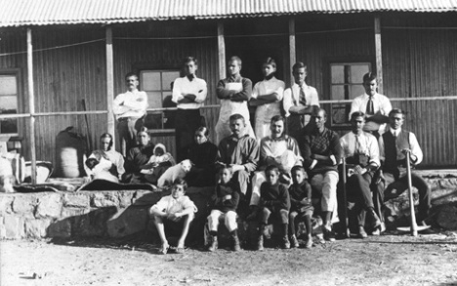
Influenced by the Gita, Gandhi wanted to purify his life by following the concepts of aparigraha (non-possession) and samabhava (equability). Then, when a friend gave him the book, Unto This Last by the European writer John Ruskin, Gandhi became excited about the Ruskin’s ideal of equality. The book inspired Gandhi to establish a communal living community called Phoenix Settlement just outside of Durban in June 1904. The Settlement was an experiment in communal living, a way to eliminate one's needless possessions and to live in a society with full equality. Gandhi moved his newspaper, the Indian Opinion, and its workers to the Phoenix Settlement as well as his own family. Besides a building for the press, each community member was allotted three acres of land on which to build a dwelling made of corrugated iron. In addition to farming, all members of the community were to be trained and expected to help with the newspaper, as well as performing tasks around the community.

Satyagraha
Gandhi came up with the concept of satyagraha in late 1906. In the very simplest sense, satyagraha is passive resistance. However, Gandhi believed the English phrase of "passive resistance" did not represent the true spirit of Indian resistance since passive resistance was often thought to be used by the weak and was a tactic that could potentially be conducted in anger.
Needing a new term for the Indian resistance, Gandhi chose the term "satyagraha," which literally means "truth force." Since Gandhi believed that exploitation was only possible if both the exploited and the exploiter accepted it, if one could see above the current situation and see the universal truth, then one had the power to make change. (Truth, in this manner, could mean "natural right," a right granted by nature and the universe that should not be impeded on by man.)
In practice, satyagraha was a focused and forceful nonviolent resistance to a particular injustice. A satyagrahi (a person using satyagraha) would resist the injustice by refusing to follow an unjust law. In doing so, he would not be angry, would put up freely with physical assaults to his person and the confiscation of his property, and would not use foul language to smear his opponent. A practitioner of satyagraha also would never take advantage of an opponent's problems. The goal was not for there to be a winner and loser of the battle, but rather, that all would eventually see and understand the "truth" and agree to rescind the unjust law.
The first time Gandhi officially used satyagraha was in South Africa beginning in 1907 when he organized opposition to the Asiatic Registration Law (known as the Black Act). In March 1907, the Black Act was passed, requiring all Indians - young and old, men and women - to get fingerprinted and to keep registration documents on them at all times. While using satyagraha, Indians refused to get fingerprinted and picketed the documentation offices. Mass protests were organized, miners went on strike, and masses of Indians illegally traveled from Natal to the Transvaal in opposition to the Black Act. Many of the protesters were beaten and arrested, including Gandhi. (This was the first of Gandhi's many jail sentences.) It took seven years of protest, but in June 1914, the Black Act was repealed. Gandhi had proved that nonviolent protest could be immensely successful.

