Leadership for Dummies:

8 Rules for Ruling the World!

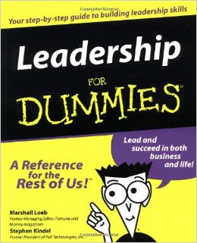

We’ve looked at how humans group themselves, elements of culture, the complexity of civilizations, and how different societies choose to rule themselves. You have worked towards compiling your claims, evidence, and explanations of 7 rules. Now, your task is to partner with another budding ruler and take the most effective aspects of these elements and compile a guide for aspiring rulers around the world!

YOUR BOOK CAN TAKE THE SHAPE OF THE POPULAR “…FOR DUMMIES” SERIES

Components of the Book
- Cover page with your name(s), a book title (be creative!), and an illustration
- Book can be bound using whatever you would like, ranging from yarn to staples to traditional bindings
- Book should follow some sort of progression—meaning start with the least important rule and progress, OR start with the most important rule and end with the least. There might be other possibilities as well…that’s up to you.
- Each page should describe one rule:
  - You can put the image on one side of the page and words on the other, but it will still count as one page
- Minimum of 7 Pages (see line above…):
  - Rule (thesis/claim)
  - Example (evidence)
  - Why this rule would work (analysis)
- You will be attaching this sheet to your book

Potential Topics
(You can use ANYTHING else from LA/SS Class thus far…)
Elements of Culture
Hunter/Gatherer/Nomads
Mesopotamia/Sumeria/Ur
Hammurabi
Egypt
Assyrians/Persians
Greeks: City-States, Democracy, Alexander
Romans: Republic & Empire

Directions: Use the checklist/rubric to help you in your book. Make sure to fill in an abbreviated Rule.
NAME/#:______________________________________NAME/#:_____________________________________

WHAT YOU NEED: Fill in your abb. Rule | CHECK (√ ) HERE IF DONE | POINTS/COMMENTS (for Steen use only…)
Title Page |  | /4
Rule #1: |  | /4
Rule #2: |  | /4
Rule #3: |  | /4
Rule #4: |  | /4
Rule #5: |  | /4
Rule #6: |  | /4
Rule #7: |  | /4
Color and Creativity |  | /4
Neatness and Overall Quality |  | /4
TOTAL: |  | /40
Writing Category (as a percentage of the total) |  | /10
Culminating Category (as a percentage of the total) |  | /10
Process Category (as a percentage of the total) |  | /20

