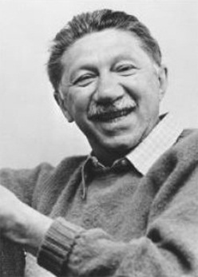
A first-rate soup is more creative than a second-rate painting!

Applying Maslow’s Theory
Let’s assume Maslow was correct (some might try to poke some holes in his argument…), and put what we’ve been doing in class into practice!
Your task: Examine and explore what you know about the following topics and use specific evidence to describe how events, practices, changes, scenarios, laws, religion, and other ways you can imagine fit into each of Maslow’s hierarchy of needs: (i.e. as innovations such as Twitter, Instagram, and Snapchat are developed in Steen’s civilization, this allows people to fulfill the deficiency need for belonging, love, and acceptance. Maslow would describe this as a Social need.)
Use the template (or create your own image…) to begin to visually represent how these different scenarios fit into Maslow’s hierarchy of needs.
Life of Pi Sumerian Culture Egyptian Culture The Elements Culture

