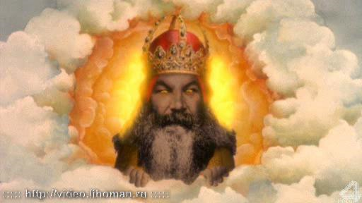
“Role of the Catholic Church”

As you read “The Role of the Church in Medieval Europe”, please do the following IN YOUR OWN NOTES:
- Write the section number (ex: 3.1) and the title (ex: Introduction)
- Beneath the section number and title take notes on the most important pieces of information in the reading. Try to limit this to 3-5 bullet points.
- Answer the attached questions AND DEFINE THESE WORDS: Monastery, Clergy, Excommunicate, Relic, Sacrament, Monasticism, Friar
EXAMPLE:
3.1 – Introduction
*Church was the center of medieval life
*Church was a community center (meetings, plays, concerts) surrounded by a town square (market)
*The church explained daily events and offered salvation (getting to heaven) for people who followed its teachings
*Middle Ages are sometimes called “The Age of Faith” because the church was so involved in people’s lives

1. In what ways did the Middle Ages impact people’s daily lives?
During the Middle Ages, the Catholic Church was both the religious and social center. The Church was responsible for hosting community events, running schools, and providing a common place for people to meet and gather. In addition to the social role of the Catholic Church, it was also responsible for administering, or giving, the sacraments to the people in order to ensure their safe trip to heaven.
3.2 –
1. How was the Roman Catholic Church organized during the Middle Ages?
2. What role did the church play in government in medieval Europe?
3. What was the subject of the conflict between Pope Gregory VII and the Holy Roman emperor, Henry IV?

3.3 –
1. During the Middle Ages, what was the purpose of sacrament, according to the teachings of the church?
2. What was the result of NOT receiving the sacraments?
3. What SEVEN sacraments were administered by the church?

3.4 –
1. What did people undertake pilgrimages during the Middle Ages? What were some of the popular destinations of pilgrims?
2. What were the Crusades?

3.5 –
1. In what ways did the art of medieval Europe reflect the influence of the Roman Catholic Church?
2. What were cathedrals? What were some of their key architectural features?

3.6 –
1. What role did the Roman Catholic Church play in education during the Middle Ages?
2. Who was Thomas Aquinas? What did he try to do with theology and ancient philosophy?

3.8 –
1. What was the monastic life like?
2. How were the lives of mendicant friars different from monks?

