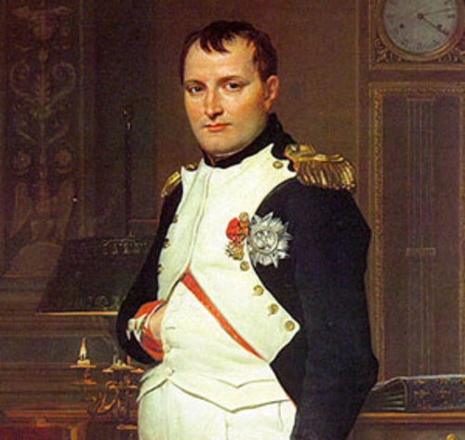

Dr. Seuss Napoleon:
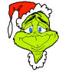

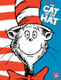

A Storybook about the Biggest Little Man in the World!

Many people do not understand the events of Napoleon’s life, or why it was significant to the people and government of France, and indeed, all of Europe. Your job is to create an informative children’s book about the rise and fall of Napoleon.
Your book should be able to be explained to children about 10 years old. You will describe and illustrate the storybook using
a number of different important events or aspects of his life. It is important to describe the events in your own words, and
you should have a minimum of three sentences per page. You may either draw the illustrations or find pictures online.

YOUR BOOK CAN, AND SHOULD, MIMICK THE STYLE AND FORMAT OF A POPULAR CHILDREN’S BOOK.

Components of the Children’s Book
- Cover page with your name(s), a book title, and an illustration
- Book can be bound using whatever you would like, ranging from yarn to staples to traditional bindings—brads, report cover, etc.
- Book should follow some sort of story with a beginning, middle, and end – ideally with a unifying theme or storytelling style
- Each page should describe at least one event in Napoleon’s life and include an image, as well as words
  - You can put the image on one side of the page and words on the other, but it will still count as one page
- Group of 1: Minimum of 10 Events/Pages, Group of 2: Minimum of 12 Events/Pages, Group of : Minimum of 14 Events/Page—COVER PAGE REQUIRED FOR ALL GROUP SIZES
- Examples of previous books will be shown in class

Potential Events in Napoleon’s Life for Your Book:
(You can use ones not on this list, and we may not have discussed all of them in detail…you can RESEARCH!)
*Childhood: Birth on Corsica, Mother’s death, Sent to boarding school in France, Military school in France, Attempts to overthrow Corsican gov’t
*Early Career: Battle of Lodi, Battle of Toulon, Egyptian Campaign, Marriage to Josephine
*Emperor: Napoleonic Code, Building of an Empire, Battle of Austerlitz, Divorce from Josephine, Marriage to Marie Louise, Birth of son (Napoleon II)
*Problems with Britain: Continental System, Trafalgar
*Fight in Spain: May 2nd, May 3rd, Goya’s “Atrocities of War”, Guerilla Warfare, Nationalism
*Russian Winter: Burning of Moscow, Retreat, Cold Winter, Failure, Elba
*The end: Waterloo, St. Helena

NAME(S):

BOOK TITLE:

Directions: Use the checklist/rubric to help you in writing the children’s book. Make sure to fill in your event names.
4=the page shows great effort, and is appropriate and displays full understanding and meaning of the topic
3=the page shows good effort, and is appropriate and displays some understanding and limited meaning of the topic
2=the page lacks in effort, and is simplistic and displays a limited understanding and meaning of the topic
1=the page shows little effort, and is not accurate, and does not display an understanding and meaning of the topic
WHAT YOU NEED | CHECK (√ ) HERE IF DONE | POINTS/COMMENTS
Title Page |  | /5
Event #1: |  | /4
Event #2: |  | /4
Event #3: |  | /4
Event #4: |  | /4
Event #5: |  | /4
Event #6: |  | /4
Event #7: |  | /4
Event #8: |  | /4
Event #9: |  | /4
Event #10: |  | /4
Event #11/12: |  | /4 (if needed—can only detract from total)
Event #13/14: |  | /4 (if needed—can only detract from total)
Color, Creativity, Neatness, and Overall Quality |  | /10
TOTAL: | /55 points | - Keep in mind: the effort and detail you put into your work will help your grade!

