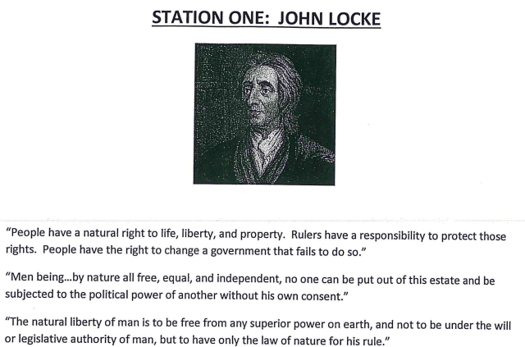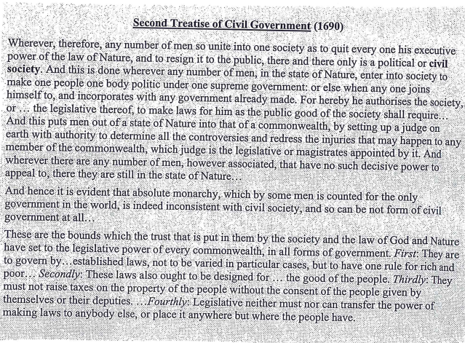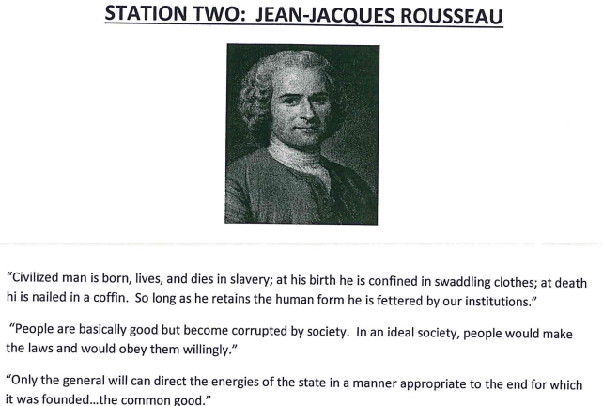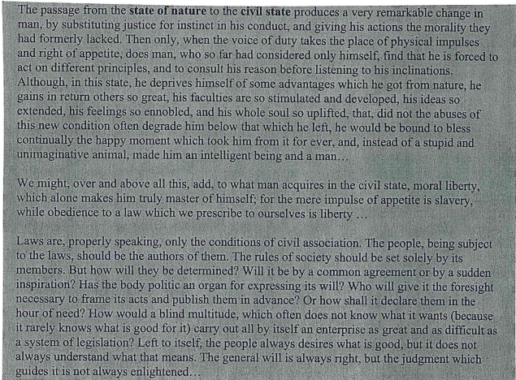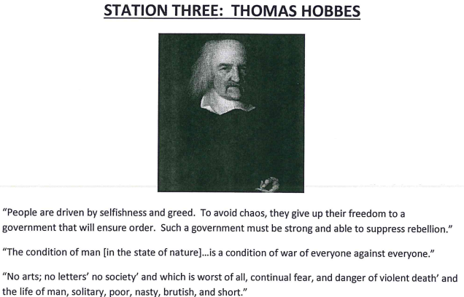

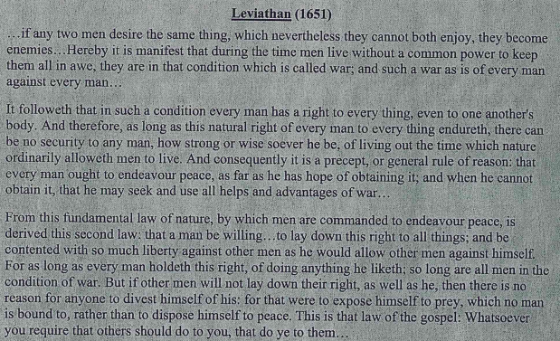
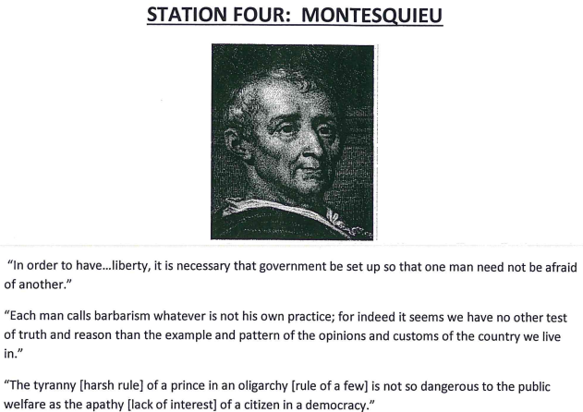 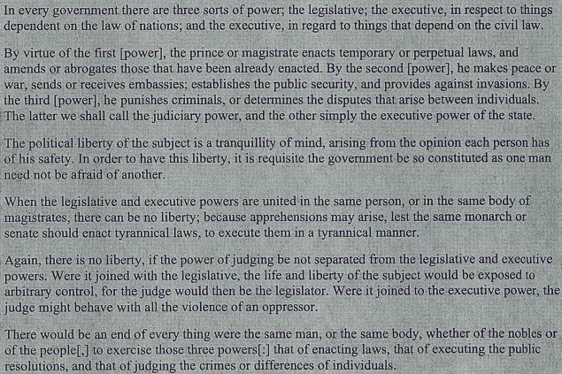 STATION FIVE: MARY WOLLSTONECRAFT

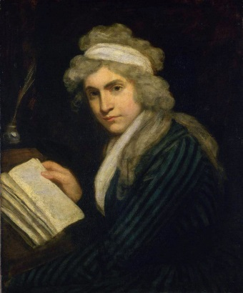
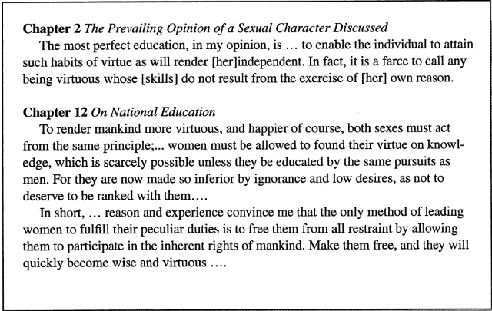
“The absurd duty, too often inculcated, of obeying a parent only on account of his being a parent, shackles the mind, and prepares it for a slavish submission to any power but reason.”
“The whole system of British politics, if system it may courteously be called, consisting in multiplying dependents and contriving taxes which grind the poor to pamper the rich…”
“The great misfortune is this, that they both acquire manners before morals, and a knowledge of life before they have from reflection, any acquaintance with the grand ideal outline of human nature. The consequence in natural; satisfied with common nature, they become a prey to prejudices, and taking all their opinions on credit, they blindly submit to authority.”
STATION SIX: VOLTAIRE
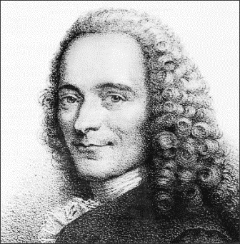
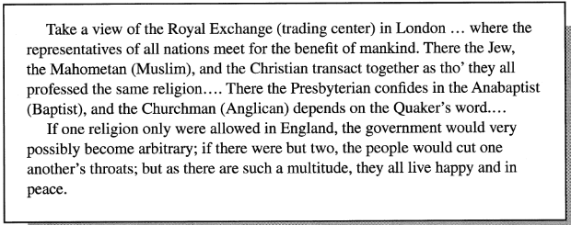

It is dangerous to be right when the government is wrong.
Men are equal; it is not birth but virtue that makes the difference.
It is forbidden to kill; therefore all murderers are punished unless they kill in large numbers and to the sound of trumpets.
Prejudice is opinion without judgment.
I disapprove of what you say, but I will defend to the death your right to say it.

STATION SEVEN: ADAM SMITH
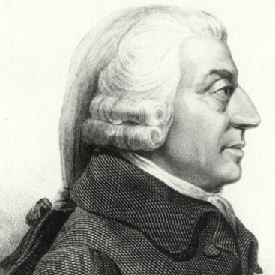

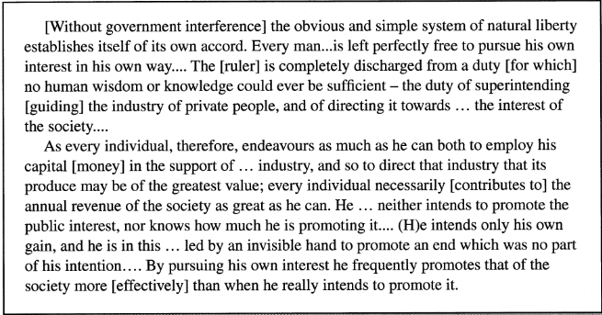
It is not from the benevolence of the butcher, the brewer, or the baker that we expect our dinner, but from their regard to their own interest.

Man is an animal that makes bargains: no other animal does this - no dog exchanges bones with another.

Science is the great antidote to the poison of enthusiasm and superstition.

It is the highest impertinence and presumption… in kings and ministers, to pretend to watch over the economy of private people, and to restrain their expense... They are themselves always, and without any exception, the greatest spendthrifts in the society. Let them look well after their own expense, and they may safely trust private people with theirs. If their own extravagance does not ruin the state, that of their subjects never will.

