Donatello’s “David” & “Soldier on Horseback”

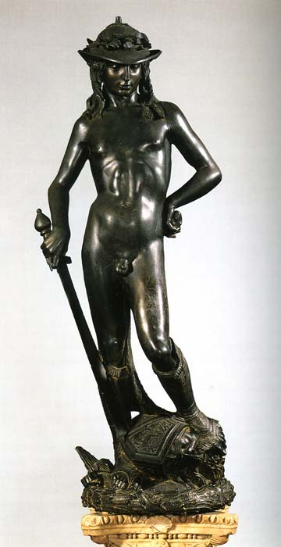 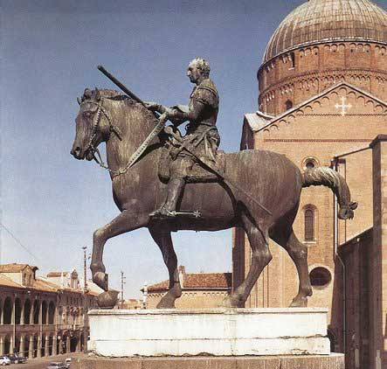

Raphael’s “School of Athens”

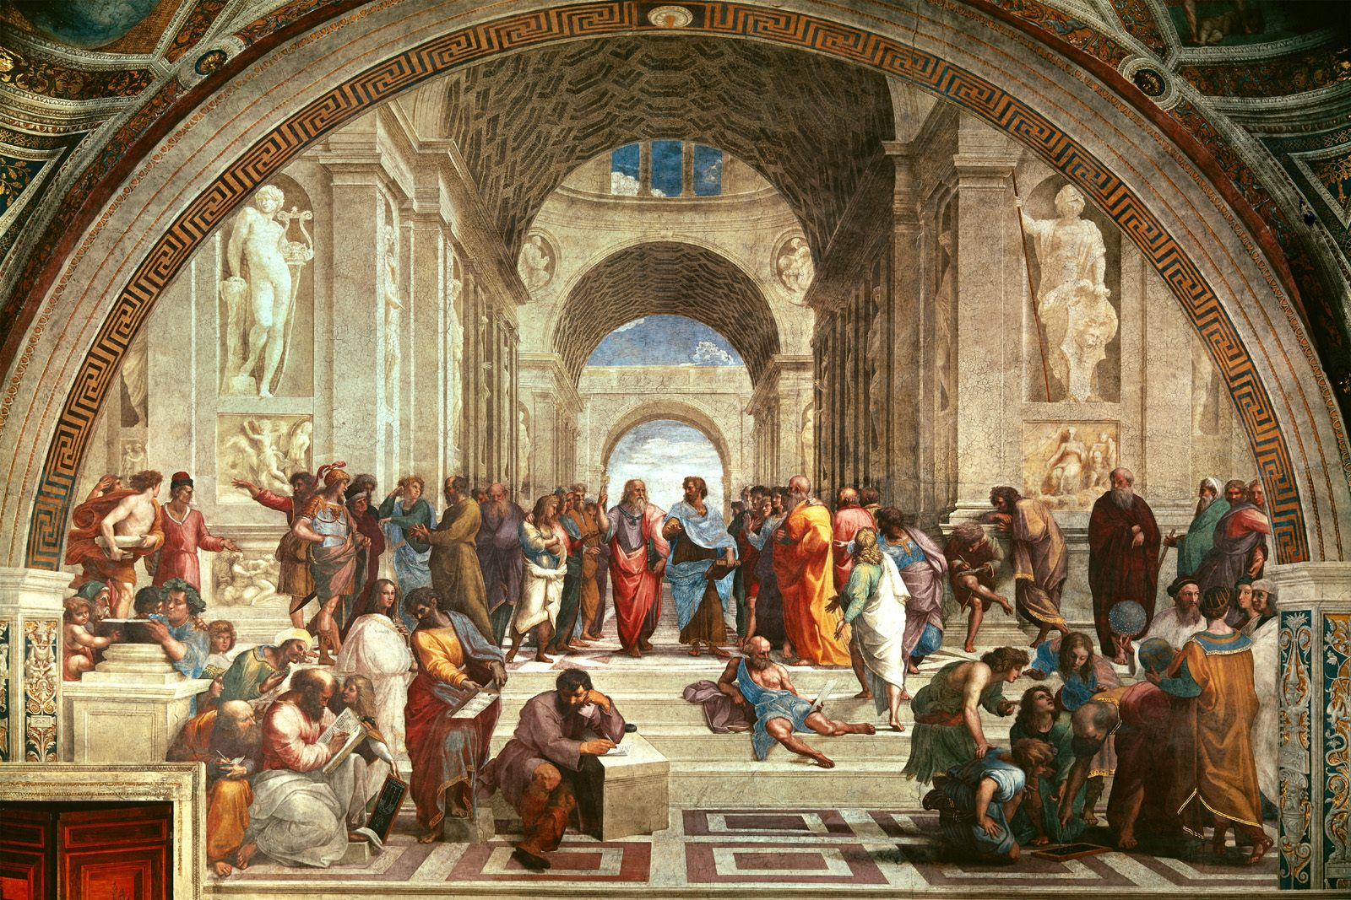

Masaccio’s “Expulsion from the Garden of Eden”

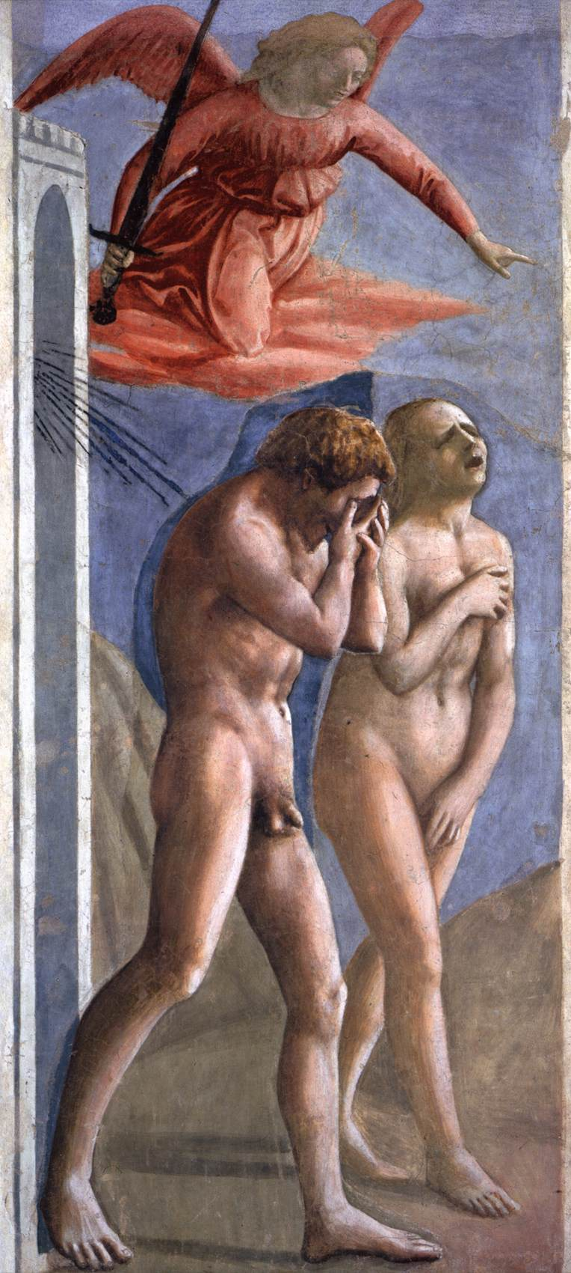

Botticelli’s “The Birth of Venus”

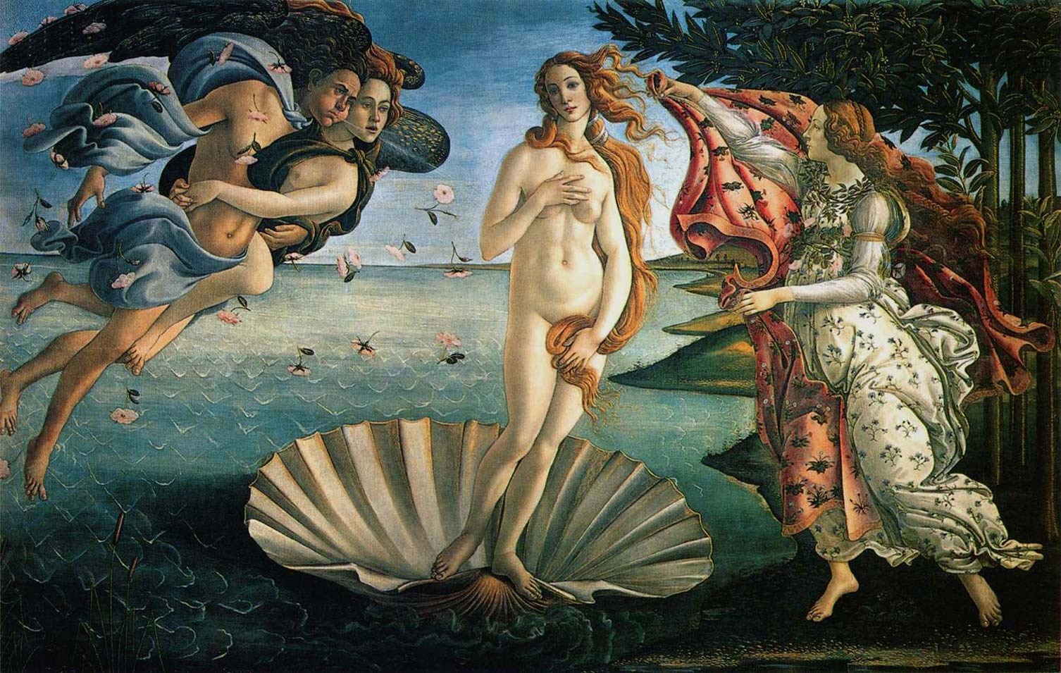

Botticelli’s “Primevera”

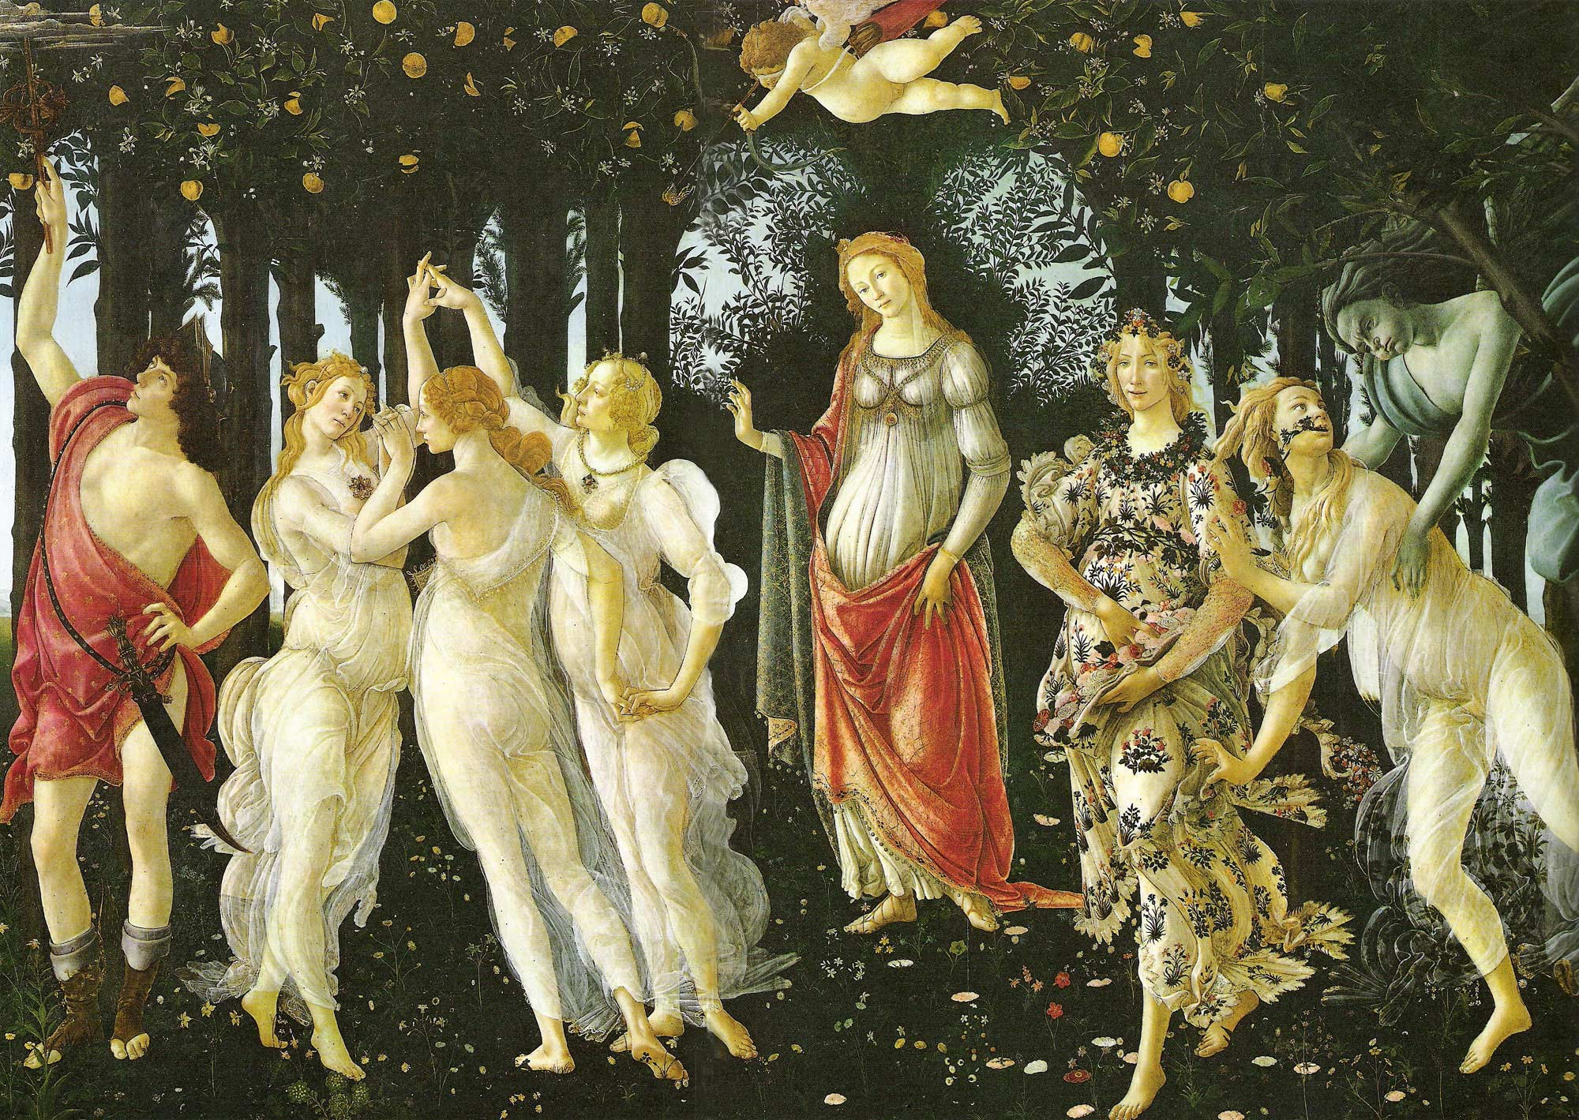

Leonardo Da Vinci’s “Mona Lisa”

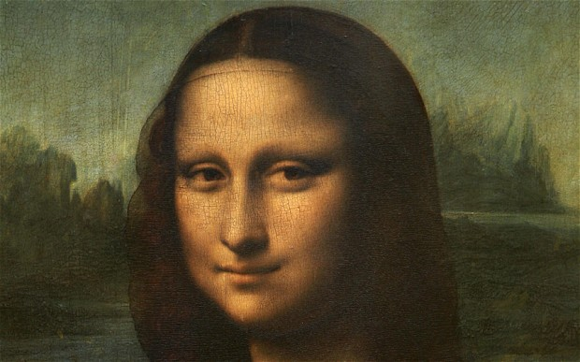

Leonardo Da Vinci’s “The Last Supper”

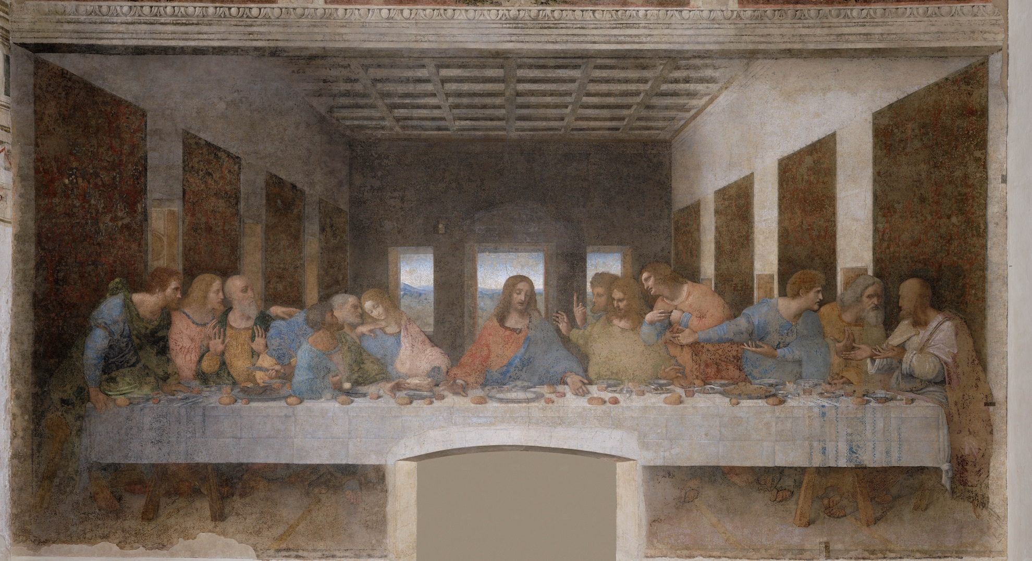

Caravaggio’s “Bacchus”

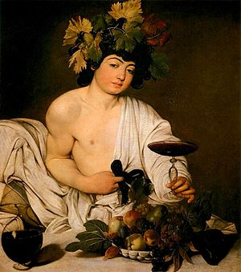

Brunelleschi’s “Sacrifice of Isaac”

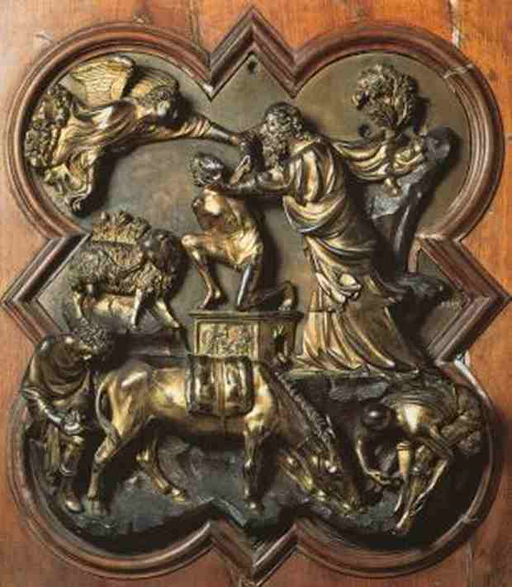

Titian’s “The Assumption of the Virgin”

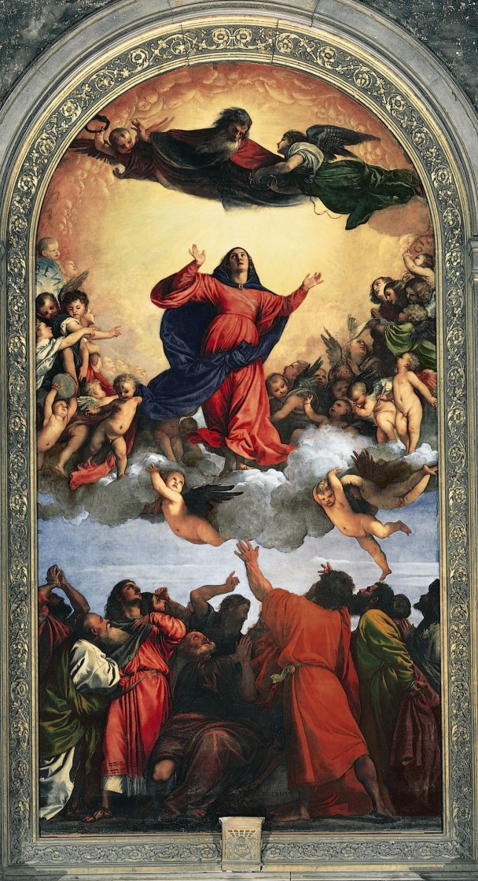

Michelangelo’s “The Pieta”

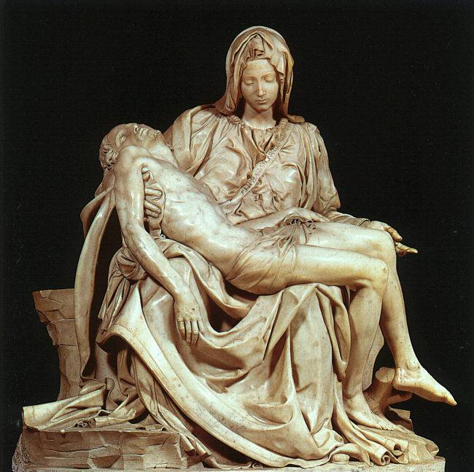

Michelangelo’s “David”

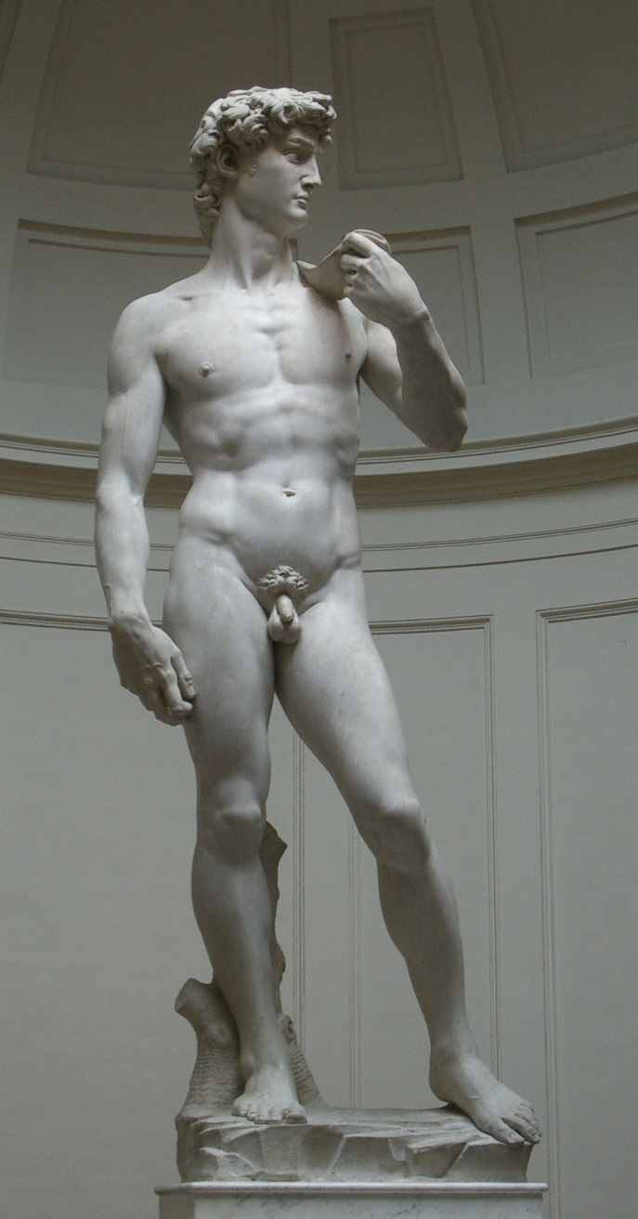

Michelangelo’s “The Creation of Adam”

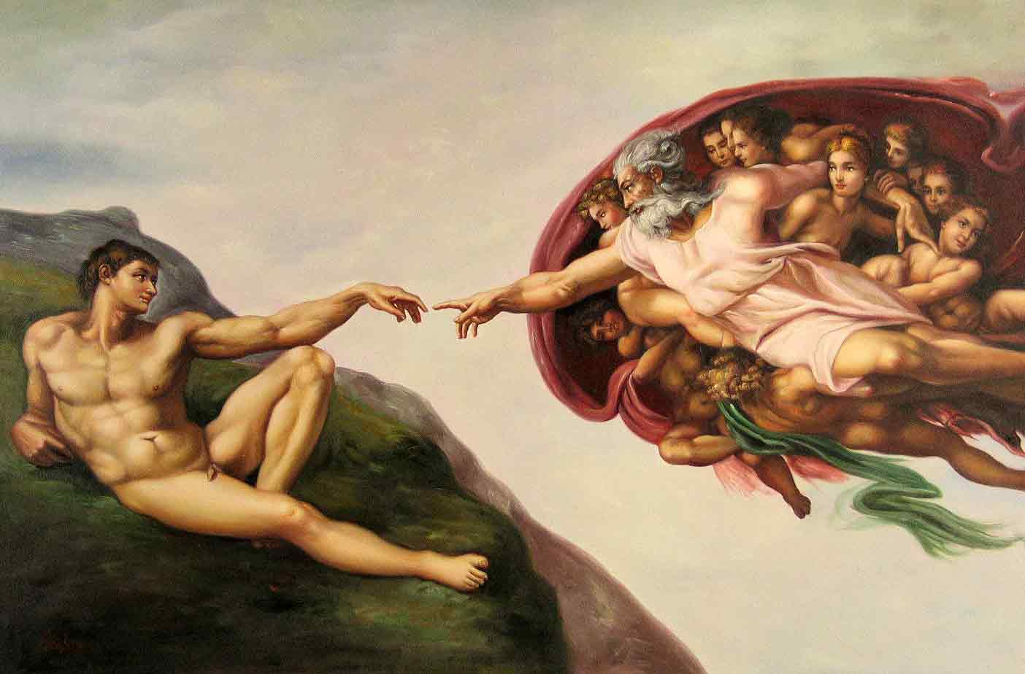

Ghiberti’s “Gates of Paradise”

