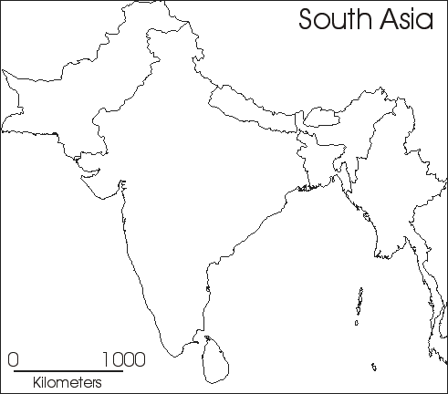 Use the atlas (pg. 118-129) to find the following information:
- Political Borders
- Physical features (elevation, land use, etc.)—Use color!
- Label the following cities—Delhi, Bombay, Calcutta, Karachi
- Label the following rivers—Indus, Ganges, Godavari, Krishna
- Label the monsoons and their seasons.
What can you say about the physical geography of India? (Please answer in complete sentences [thoughts])
- What advantages does India have?

- What challenges will India face?

- Where will civilization arise?

- Where will invasions come from?

