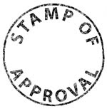
STAMP SHEET #:___ Name _________________________________
- You are required to bring this sheet to class every day. No Sheet=No Points
- DO NOT LOSE this stamp sheet. Each stamp is worth 2 points. Turn in @ end of column…again, NO SHEET=NO POINTS!
- General absence policy applies. NO LATE WORK ACCEPTED!
Date | Title | Stamp | Date | Title | Stamp
Date | Title | Stamp | Date | Title | Stamp

