The Great Leap Forward
Mao’s Big Gamble

The Great Leap Forward was a push by Mao Zedong to change China from a predominantly agrarian (farming) society to a modern, industrial society in just five years.
Between 1958 and 1960, millions of Chinese citizens were moved onto communes (farms and factories owned and run by the government). Some were sent to farming cooperatives, while others worked in small manufacturing. All work was shared on the communes; from childcare to cooking, daily tasks were collectivized.
Mao hoped to increase China's agricultural output. He relied, however, on nonsensical Soviet farming ideas, such as planting crops very close together so that they could support one another, and plowing up to six feet deep to encourage root growth.
Mao also wanted to free China from the need to import steel and machinery. He encouraged people to set up back-yard steel furnaces, where citizens could turn scrap metal (and their own pots, pans and farm implements) into usable steel.
The results were predictably bad. Backyard smelters run by peasants with no metallurgy training produced such low-quality iron that it was worthless.
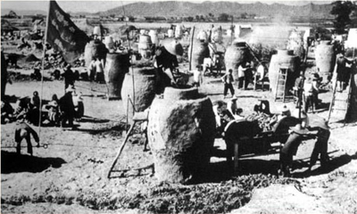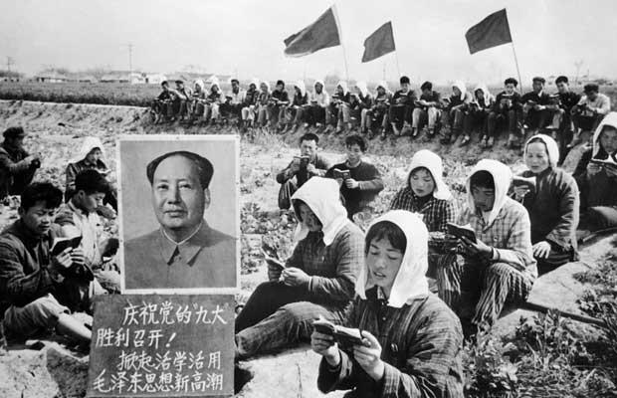
Over just a few years, the Great Leap Forward caused massive environmental damage in China. The backyard steel production plan resulted in entire forests being burned to fuel the smelters, which left the land open to erosion. Dense cropping and deep plowing stripped the farmland and left if vulnerable, as well.
When autumn of 1958 came, many areas had a bumper crop, since the soil was not yet exhausted. However, so many farmers had been sent into steel production work that there weren't enough hands to harvest the crops.
Anxious commune leaders vastly exaggerated their harvests, hoping to curry favor with the Communist leadership. As a result, Party officials carried off most of the food to serve as the cities' share of the harvest, leaving the farmers with nothing to eat. People in the countryside began to starve.
The next year, the Yellow River flooded, killing 2 million people either by drowning or by starvation after crop failures. In 1960, a wide-spread drought added to the nation's misery.
In the end, through a combination of disastrous economic policy and adverse weather conditions, an estimated 20 to 48 million people died in China. Most starved to death in the countryside.
The official death toll from the Great Leap Forward is "only" 14 million, but most scholars agree that this is a substantial underestimate.
The Great Leap Forward was supposed to be a 5-year plan, but it was called off after just three tragic years. The period between 1958 and 1960 is known as the "Three Bitter Years" in China.

The Cultural Revolution
Mao’s next big gamble

Between 1966 and 1976, the young people of China rose up in an effort to purge the nation of the "Four Olds": old customs, old culture, old habits and old ideas.
In August, 1966, Mao Zedong called for the start of a Cultural Revolution. He urged the creation of corps of "Red Guards" to punish party officials and any other persons who showed bourgeois tendencies.
Mao likely was motivated to call for the so-called Great Proletarian Cultural Revolution in order to rid the Chinese Communist Party of his opponents after the tragic failure of his Great Leap Forward policies. Mao knew that other party leaders were planning to marginalize him, so he appealed directly to his supporters among the people to join him in a Cultural Revolution. He also believed that communist revolution had to be a continuous process, in order to stave off capitalist ideas.
Mao's call was answered by the students, some as young as elementary school, who organized themselves into the first groups of Red Guards. They were joined later by workers and soldiers.
The first targets of the Red Guards included Buddhist temples, churches and mosques, which were razed to the ground or converted to other uses. Sacred texts, as well as Confucian writings, were burned, along with religious statues and other artwork. Any object associated with China's pre-revolutionary past was liable to be destroyed.
In their fervor, the Red Guards began to persecute people deemed "counter-revolutionary" or "bourgeois," as well. The Guards conducted so-called "struggle sessions," in which they heaped abuse and public humiliation upon people accused of capitalist thoughts (usually these were teachers, monks and other educated persons). These sessions often included physical violence, and many of the accused died or ended up being held in reeducation camps for years. According to the Mao's Last Revolution by Roderick MacFarquhar and Michael Schoenhals, almost 1,800 people were killed in Beijing alone in August and September of 1966.
By February, 1967, China had descended into chaos. The purges had reached the level of army generals who dared to speak out against the excesses of the Cultural Revolution, and Red Guards groups were turning against one another and fighting in the streets. Mao's wife, Jiang Qing, encouraged the Red Guards to raid arms from the People's Liberation Army (PLA), and even to replace the army entirely if necessary.
By December of 1968, even Mao realized that the Cultural Revolution was spinning out of control. China's economy, already weakened by the Great Leap Forward, was faltering badly. Industrial production fell by 12% in just two years. In reaction, Mao issued a call for the "Down to the Countryside Movement," in which young cadres from the city were sent to live on farms and learn from the peasants. Although he spun this idea as a tool for leveling society, in fact Mao sought to disperse the Red Guards across the country, so that they could not cause so much trouble anymore.

After-effects of the Cultural Revolution
For the entire decade of the Cultural Revolution, schools in China did not operate; this left an entire generation with no formal education. All of the educated and professional people had been targets for reeducation. Those that hadn't been killed were dispersed across the countryside, toiling on farms or working in labor camps.
All sorts of antiquities and artifacts were taken from museums and private homes; they were destroyed as symbols of "old thinking." Priceless historical and religious texts also were burned to ashes.
The exact number of people killed during the Cultural Revolution is unknown, but it was at least in the hundreds of thousands, if not millions. Many of the victims of public humiliation committed suicide, as well..
Terrible mistakes and brutal violence mar the history of Communist China. The Cultural Revolution is among the worst of these incidents, not only because of the horrific human suffering inflicted, but also because so many remnants of that country's great and ancient culture were willfully destroyed.

