WH9: Friday Review Introduction & the Catholic Church

Introduction
In this class we will use each Friday to review the week’s topics. This will include a few review questions (use the book to answer them) and some terms and people that should be added to your Field Guide (Automatic 5% Extra Credit if all completed – plus they will help you study!). You should hole-punch each notecard and add it to your ring, place in your binder, or notecard box, etc. Often times, as you work on completing your Friday work I will do a journal check. WHATEVER YOU DO NOT COMPLETE IN CLASS SHOULD BE DONE AS HOMEWORK OR DURING TUTORIAL/AT.
Terms
For each of the following terms you should write it on one side of your notecard and define it IN YOUR OWN WORDS and any other relevant information on the back of the notecard.
Excommunicate Common Law Habeus Corpus Sacraments Natural Law Pilgrimage
People
For each of the following people you should cut out their picture and paste it to your notecard and on the back write their significance (why are they important) and any other relevant information. Make sure you cut the person’s name out along with the picture!
____________________________________________________________________________________________________________________________ William the Conqueror King John Thomas Aquinas Pope Gregory VII Henry IV
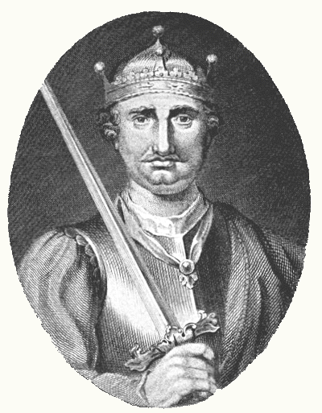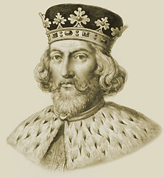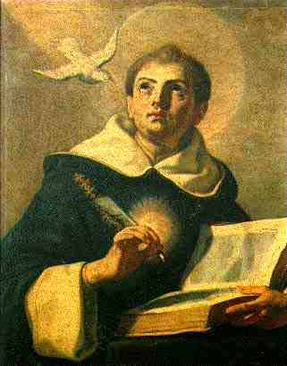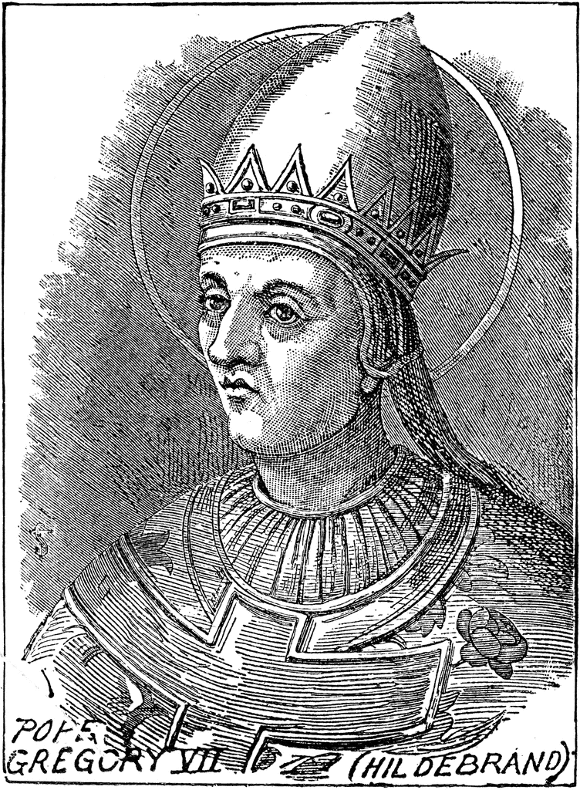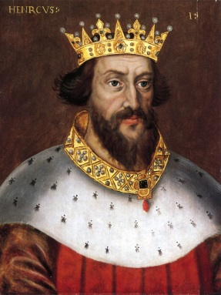

Checkpoint Questions (Chapter 8, Section 1)—Complete in your journal and have it stamped when your done.
- What groups gained and lost power?
- How did William and Henry II increase royal power?
- How was the power of the English king limited?
- Describe how two French kings increased royal power.

